Fair Access Action Plan
2024—2028

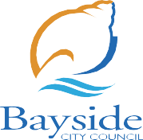

Bayside City Council proudly acknowledges the Bunurong People of the Kulin Nation as the Traditional Owners and Custodians of this land, and we pay our respects to their Elders past, present and emerging.

Context

Vison: Women & girls can participate at their
full potential on & off the field!

Background

This Action Plan outlines how Bayside City Council will deliver on the Fair Access Policy (‘the Policy’), which addresses known barriers experienced by women and girls in accessing and using community sport and recreation infrastructure, whilst also supporting inclusive opportunities for the sports and active recreation community. The sport and active recreation sector provide opportunities for enriching our communities through the promotion of respect and fair mindedness for all people, while also supporting the physical and mental wellbeing of all.

Sport and active recreation are a highly visible and valued feature of Bayside City Councils culture and identity. The primary focus of the Policy is to promote women and girls’ opportunities in the sports and active recreation community. Bayside is advocating, supporting and providing opportunities for women and girls in a number of ways such as providing female friendly pavilions, sportsground lighting and other infrastructure that supports enhanced utilisation and safer inclusive spaces. Council also advocates for women and girls to have prioritised access to facilities such as pavilions and sports grounds.

Purpose

The Policy and Action Plan will enable Council to take steps towards a level playing field for women and girls in sport and active recreation. We do this so women and girls can fully participate in and enjoy all the benefits of what community sport right through to senior leadership roles has to offer. The purpose of the Fair Access Action Plan is to illustrate Councils responsibilities to ‘Change The Game’ in the community. Council will aim to work collaboratively alongside community sport and active recreation clubs, governing bodies, sports leagues and associations, and the broader community. Council is well positioned to implement the Action Plan that progresses gender equity.

Guiding Principles

The Office for Women in Sport and Recreation at the Victorian Government has developed 6 Guiding Principles in collaboration with representatives from local government and the state sport and recreation sector. Bayside City Council is committed to all 6 Principles that represent the inclusivity for full participation and equal representation. Our Council Actions align to these Principles, with Council having a more active role to play in relation to Principles 1, 5 and 6, with more of a collaboration and advocacy role for Principles 2, 3, and 4, although all principles coincide with the impact they will have on the community.

- Community sports infrastructure and environments are genuinely welcoming, safe, and inclusive.
- Women and girls can fully participate in all aspects of community sport and active recreation including as a player, coach, administrator, official, volunteer and spectator.
- Women and girls will have equitable access to and use of community sport infrastructure:
  - of the best available and most convenient
  - at the best and most popular competition and training times and locations
  - to support existing and new participation opportunities, and a variety of sport.
- Women and girls should be equitably represented in leadership and governance roles.
- Encourage and support all user groups who access and use community sport infrastructure to understand, adopt and implement gender equitable access and use practices.
- Prioritise access, use and support to all user groups who demonstrate an ongoing commitment to gender equitable access and use of allocated community sport infrastructure.

Key Objectives

- To promote and build the capacity and capabilities of Council in the identification and elimination of systemic causes of gender inequity in policy, programs, communications, and delivery of services to women and girls in community sport and recreation.
- To ensure best-practice position for gender equitable use, access and upgrades of community sports and active recreation infrastructure.
- To educate and build the knowledge, support and understanding of community sport and active recreation clubs to advocate for women and girls to reach their potential on and off the field.
- The commitment to prioritise and call out inequalities regards to fair access. 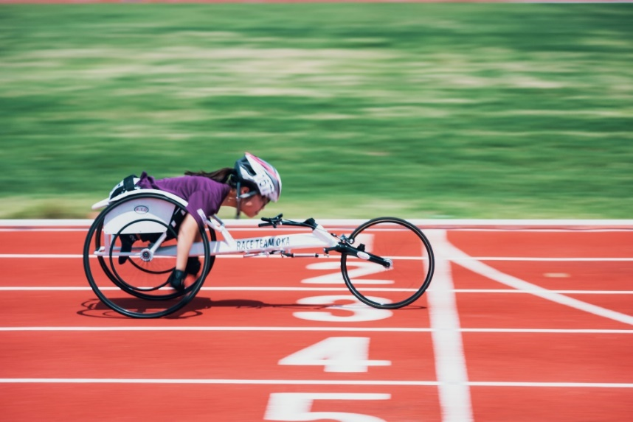

Measuring Success

Council is committed to reporting to the Office for Women in Sport and Recreation and local sport and active recreation clubs on the Action Plan. All actions in the Action Plan will be entered into Council’s reporting platform and progress indicators will apply, which will be regularly reviewed and reported.

Data will be obtained from a state and national perspective to benchmark with data collected at Bayside. A strong indicator of success with the Action Plan is seeing increased participation programs, pathways, and leadership opportunities for women and girls. Council will look to promote and celebrate success and improvements in this important area.

Legislation and Policy

Bayside’s 2050 Vision is to lead the way as a diverse, healthy, and liveable place. Fair Access for women and girls is a non-negotiable at Bayside and everyone in our community should have fair, reasonable and equitable access to the spaces and facilities they desire.

The Victorian Government, led by the Office for Women in Sport and Recreation, requires all Victorian Councils to have a Fair Access Policy and Action Plan by 1 July 2024 to help work towards a future where there is a level playing field for women and girls in sport and active recreation. The Policy enables effective and efficient integration of the requirements of the Gender Equality Act 2020, and other legislative frameworks.
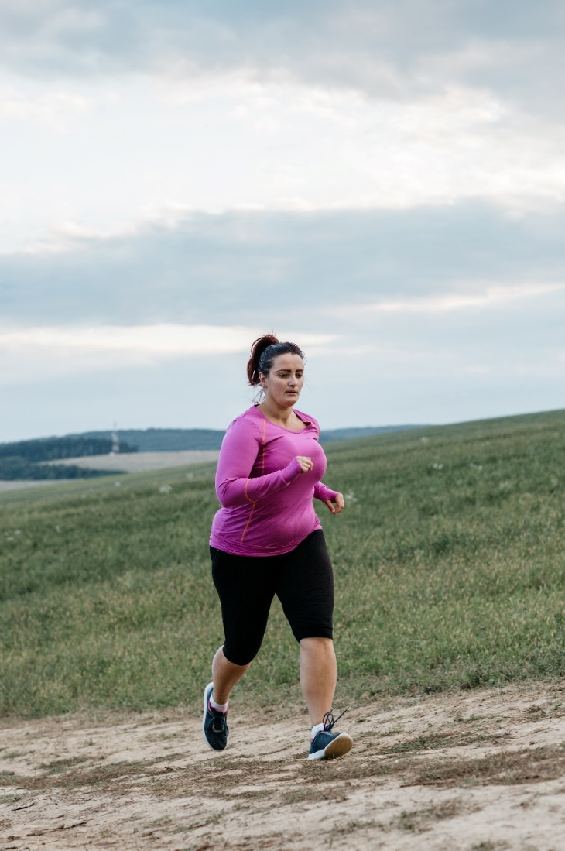

Council Actions

Principle 1 - Community sports infrastructure and environments are genuinely welcoming, safe, and inclusive

Actions | Outcomes | Responsibility | Timeframe
- Council will provide safe, welcoming and inclusive infrastructure and environments for sport and active recreation. (Eg. Sports Pavilions, Sportsgrounds, Recreation infrastructure, sports Lighting, Playgrounds). | - Deliver capital works and infrastructure projects that support women and girls’ safety and inclusion.  - Deliver Masterplans, strategic plans and feasibility studies that support welcoming, safe and inclusive environments.  - Consider opportunities to provide more welcoming and inclusive environments, such as cleaning of assets, use of sanitary bins, etc.  - Undertake asset condition inspections of community recreation infrastructure to assess the suitability for women and girls both informal and formal recreation. | - Council | On-going

Principle 2 - Women and girls can fully participate in all aspects of community sport and active recreation including as a player, coach, administrator, official, volunteer and spectator.

Actions | Outcome | Responsibility | Timeframe
- Council will support, partner, and promote sports and active recreation groups or initiatives that are endeavouring to support women and girls. | - Share, promote, and partner with stakeholders for participation opportunities of women and girls across the community.  - Partner, support, and assist community programs and events for women and girls to get active and report successes. (e.g. Sports Club ‘Come n Try’ programs, ‘This Girls Can’ campaign, Get Active Victoria, ‘Step-tember’, 16 days of activism, etc) | - Council  - Partner with key providers and stakeholders  - Partner with Sport and Recreation Clubs/Associations/Leagues | Medium
2.2 Council to promote different aspects of women and girls in sport and active recreation. | - Enhance signage, promotional material and collateral for facilities and communication channels to support and promote positive gender lens. | - Council | On-going

Principle 3 - Women and girls will have equitable access to and use of community sport infrastructure.

of the best available and most convenient

at the best and most popular competition and training times and locations

to support existing and new participation opportunities, and a variety of sport.

Actions | Outcome | Responsibility | Timeframe
3.1 Council will collaborate with key stakeholders to provide ways of showcasing that they are leveling the playing field. | - Collect data on clubs when they are allocating events, training, and games to monitor and measure change.  - Support and guide consultation with players, coaches and parent/guardians to understand the needs of their women and girls on the equitable access and use of infrastructure.  - Collaborate and engage with Clubs and Associations about their equitable access arrangements. (Eg. fixtures, uniforms, changerooms etc.) | - Council  - Partner with Sport and Recreation Clubs/Associations/Leagues | Medium

Principle 4 - Women and girls should be equitably represented in leadership and governance roles.

Actions | Outcome | Responsibility | Timeframe
4.1 Council will lead and support women and girls ‘champions’ of change. | - Aim to create a platform for a ‘Women and Girls Champion’ advocacy network within Bayside.  - Liaise with key stakeholders and partners to support women and girl’s pathway opportunities, education opportunities and participation growth.  - Investigate opportunities for mentorship and leadership programs for club members and participants. | - Council  - Partner with key stakeholders  - Partner with Sport and Recreation Clubs/Associations/Leagues | High
4.2 Council will support and provide resources and opportunities for empowering leaders. | - Partner with key providers to deliver opportunities for networking, officiating, or upskilling to empower women and girls in sport and recreation (player, coaching, officiating, administrator, volunteer).  - Investigate opportunities for resources and training that are accessible and inclusive for all. | - Council  - Partner with key providers and stakeholders | Medium

Principle 5 - Encourage and support all user groups who access and use community sport infrastructure to understand, adopt and implement gender equitable access and use practices.

Actions | Outcome | Responsibility | Timeframe
- Council will support programs and seek resources that provide equal access for diverse users. | - Seek funding and grant opportunities to engage and support women and girls.  - Plan opportunities to support women and girls to access and use facilities.  - Partner or provide key stakeholders opportunities to deliver awareness, programs or services to facilitate equitable use of facilities. | - Council  - Partner with key stakeholders, Sport and Recreation Clubs/Associations/Leagues | On-going
- Council will guide and support clubs to outline their aspired goals to create equitable access and use practices. | - Support clubs with self-assessment tools in order to gather relevant data and undertake reporting.  - Provide offer to assist clubs in developing their Action Plans that aligns to their State Sporting Associations, local league and their own priorities to support women and girls’ participation, create welcoming and safe environments, and leadership and governance opportunities aligning to the 6 Principles.  - Provide clubs useful and practical resources and tools to adopt equitable practices. | - Council  - Partner with State Sporting Associations, National Sporting Organisations and Australian Sports Commission  - Partner with Sport and Recreation Clubs/Associations/Leagues | On-going

Principle 6 - Prioritise access, use and support to all user groups who demonstrate an ongoing commitment to gender equitable access and use of allocated community sport infrastructure.

Actions | Outcome | Responsibility | Timeframe
- Council will review and update internal communication, processes and documentation to support women and girls access and use in sport and recreation. | - Review and update aligned documentation to advocate for women and girls.  - Provide and support grant and funding opportunities for sport and active recreation clubs.  - Advocate for local community events that have inclusive practices. | - Council | High
- Council Recreation Officers will attend upskilling opportunities related to Gender Equity and Fair Access | - Council Officers to have a strong understanding of the impacts that gender equity will have in the sport and recreation community.  - Investigate opportunities to educate community groups about the importance of gender equity. | - Council | Medium
- Council will review and update as required the Sports Facility User Guidelines and Facility User Agreements to include relevant Fair Access information and Actions. | - Clubs Hire Agreements to be reviewed with a gender lens  - Sports Facility User Guidelines reviewed and updates communicated  - Prioritise the ‘hierarchy of allocations’ for facility users’ applications to access facilities. | - Council  - Partner with State Sporting Associations, National Sporting Organisations and Australian Sports Commission | High

