Electric Line Clearance Management Plan

2024-2025

|  |  |  |  |  |
| --- | --- | --- | --- | --- |
| Document Version | Revision Date | Issue Number | Responsible By | Authorisation Date |
| Version 1 | March 2024 | 1 | Jill Colson, Director, Environment, Recreation and Infrastructure | 31 March 2024 |
| Signature : | | |  |  |

**This plan supersedes all previous plans**

Contents

9(2) A responsible person that is not a major electricity company, before 31 March in each year, must prepare a management plan relating to compliance with the Code for the next financial year 4

9(4)(a) Name, Address and Telephone Number of the Responsible Person. 4

9(4)(b) Name, Position, Address and Telephone Number of the Person who was responsible for the Preparation of the Plan. 4

9(4)(c) Name, position, address and telephone number of the persons who are responsible for carrying out the plan. 4

9(4)(d) The telephone number of a person who can be contacted in an emergency that requires clearance of an electric line that the responsible person is required to keep clear of trees 5

9(4)(e) The objectives of the plan are to ensure Electrical Safety through: 6

9(4)(f) The land to which this management plan applies. 7

9(4)(h) Each area that the responsible person knows contains a tree that the responsible person may need to cut or remove to ensure compliance with the Code and that is—……………. 7

9(4)(i) the means which the responsible person will use to identify a tree of a kind specified in paragraph (h)(i), (ii) or (iii); 8

9(4)(j) The management procedures that the responsible person is will adopt to ensure compliance with the code including: 9

i) Details of the methods to be adopted for managing trees and maintaining a minimum clearance space as required by the code: 9

(ii) Specify the method for determining an additional distance that allows for cable sag and sway for the purpose of determining a minimum clearance space in accordance with Part 3 Division 1 of the Code: 10

9(4)(k) The procedures to be adopted if it is not practicable to comply with the requirements of AS 4373 while cutting a tree in accordance with the Code; 11

9(4)(l) A description of each alternative compliance in respect of which the responsible person has applied, or proposes to apply, for approval under clause 31 of the Code. 12

9(4)(m) Details of each alternative compliance mechanism that is held by : 13

9(4)(n) A description of the measures that must be used to assess the performance of the responsible person under this management plan. 13

9(4)(o) Details of the audit processes that must be used to determine the responsible person’s compliance with the Code: 14

9(4(p) The qualifications and experience that the responsible person must require of the persons who are to carry out the inspection, cutting or removal of trees in accordance with the Code and the Electricity Safety (General) Regulations 2019 15

9(4)(q) Notification and consultation procedures, including the form of the notice to be given in accordance with Division 3 of Part 2 of the Code 17

9(4)(r) A procedure for the independent resolution of disputes relating to electric line clearance; 17

Dispute resolution procedures – see Appendix 5 for matrix 17

(s) If Energy Safe Victoria has granted an exemption under regulation 11 relating to a requirement of the Code, details of the exemption or a copy of the exemption. 18

10 Bayside Council obligations relating to the management plan 18

The following sections are as per Regulation 9(4) (Preparation of Management Plan) of the Electricity Safety (Electric Line Clearance) Regulations 2020. 20

4. Exception to minimum clearance space for structural branches around insulated low voltage electric lines 20

5. Exception to minimum clearance space for small branches around insulated low voltage electric lines 20

6(2) Exception to minimum clearance space for small branches growing under uninsulated low voltage electric lines in low bushfire risk areas 21

7. Exception to minimum clearance space for structural branches around uninsulated low voltage electric lines in low bushfire risk areas 21

9. Responsible person may cut or remove hazard tree 22

10 Cutting of tree to comply with Standard 22

11 Cutting or removal of indigenous or significant trees must be minimised 22

12 Cutting or removing habitat for threatened fauna 22

20. Duty relating to the safety of cutting or removal of trees close to an electric line 22

Appendix 1 – Bayside City Council Map. 24

Appendix 2 – Cyclic maintenance program 25

Appendix 3 – VPO3 area (shaded green) – Black Rock, Beaumaris and part of Cheltenham 26

Appendix 4 – Significant trees in public open space 28

Appendix 5 Dispute Resolution Matrix 29

Appendix 6 Table outlining KPI’s for audit program 29

Appendix 7 – Schedule 2 – Applicable distance for middle two thirds of a span of an electric line – all areas 32

Graph 1 – Insulated electric lines in all areas 32

Graph 1 formula 32

Graph 2 – Uninsulated low voltage electric line in Low Bush Fire Risk Area 33

Graph 2 formula 33

Graph 3 – Uninsulated High Voltage Electric Line (other than 66kV line) in LBRA 34

Graph 3 formula 34

Graph 4 – Uninsulated 66kV line in LBRA 35

Graph 4 formula 35

**Electric Line Clearance Management Plan Submitted By:**

**Responsible Person: Bayside City Council**

**Date: 31 March 2024**

***The following sections are as per Regulation 9 (Management and submission of Plans) of the Electricity Safety (Electric Line Clearance) Regulations 2020.***

## 9(2) A responsible person that is not a major electricity company, before 31 March in each year, must prepare a management plan relating to compliance with the Code for the next financial year

A management plan relating to compliance with the Code for the next financial year will be prepared by 31 March each year. The Electric Line Clearance Management Plan Arborist (Open Space Arborist) will be responsible for the preparation of this plan and will ensure all relevant standards, policies, training, registers and documents are current.

## 9(4)(a) Name, Address and Telephone Number of the Responsible Person.

**Name:** Mick Cummins

**Position:** Chief Executive Officer

**Business Address:** 76 Royal Avenue, Sandringham, Victoria, 3191

**Telephone No.:** +61 3 9599 4444

**Email Address:** enquiries@bayside.vic.gov.au

## 9(4)(b) Name, Position, Address and Telephone Number of the Person who was responsible for the Preparation of the Plan.

**Name:** Jill Colson

**Position:** Director Environment, Recreation and Infrastructure

**Business Address:** 76 Royal Avenue, Sandringham, Victoria, 3191

**Telephone No.:** +61 3 9599 4444

**Email Address:** enquiries@bayside.vic.gov.au

## 

## 9(4)(c) Name, position, address and telephone number of the persons who are responsible for carrying out the plan.

**Name:** Adrian Runco

**Position:** Open Space Arborist

**Business Address:** 76 Royal Avenue, Sandringham, Victoria, 3191

**Telephone No.:** +61 3 9599 4444

**Email Address:** enquiries@bayside.vic.gov.au

**Name:** Mark Fusco

**Position:** Operational Leader - Citywide

**Business Address:** 9 -11 Kilpa Road Moorabbin Vic 3189

**Telephone No.:** 03 9257 5123

**Email Address:** mark.fusco@citywide.com.au

## 

## 9(4)(d) The telephone number of a person who can be contacted in an emergency that requires clearance of an electric line that the responsible person is required to keep clear of trees

##### The City of Bayside’s Emergency after-hours Contact Number

+61 3 9599 4444

## 9(4)(e) The objectives of the plan are to ensure Electrical Safety through:

1. **Public safety and continuity of electricity supply.**

Ensure that trees are pruned to standards and practices to ensure public safety and continuity of electricity supply.

1. **Provide a safe working place for employees and responsible persons.**

Requires that all work conducted on trees is undertaken by suitably trained workers who have qualifications in arboriculture or suitable experience and/or in the process of obtaining qualifications.

1. **Compliance with the Code of Practice for Electric Line Clearance 2020 and to ensure electrical safety.**

Tree Policy requires that all trees are pruned to the Electricity Safety (Electric Line Clearance) Regulations 2020.

The Bayside Street Tree Selection Guide 2016 includes the presence of electric lines in the street as one of the criteria for selection of suitable species for its streets.

Council requires its staff and contractors to have experience and expertise in quality management, OH&S systems and environmental management systems to ensure compliance with Industry Standards and the City of Bayside requirements.

1. **Management of vegetation to maximize the amenity value of the Responsible person’s street trees.**

* Tree database records inspections and works undertaken on all public trees.
* Records inspections and works in City of Bayside’s current tree data base.
* Provides an annual pruning program to maintain minimum clearance space from High Voltage lines and a two-year cyclic pruning program to maintain minimum clearance space for trees from Low Voltage electric lines. The adoption of these programs has resulted in a reduction of the volume of vegetation removed and an improvement to the long-term health and safety of the trees. This ensures compliance with the current regulations and maintains the amenity value of the trees.
* Identifies where spreaders are required under s.6(2)(b)(i) & (ii) of the Regulations as a tool to manage structural branches.
* Undertakes monthly zone audits to ensure the City of Bayside’s trees are being maintained to ensure maximum amenity value.
* Citywide is required to notify the City of Bayside of any structural branches within the clearance space and likely to significantly impact tree canopy over 30%.

1. **Protect areas of significant vegetation and high amenity value.**

The City of Bayside has several heritage trees that are protected under Heritage and Environmental Overlays as outlined in 9(4)(h) of this document.

* Areas and trees of significant vegetation and high amenity value are subjected to an increased inspection regime.
* All inspections are recorded on the tree database.
* The Open Space Contract Manager will be responsible for updating the significant tree list and forwarding updates to the Citywide.

1. **Assist Distribution Businesses in achieving reliability of supply and minimising fire starts.**

* the City of Bayside will endeavour to assist the Distribution Business to achieve reliability of supply and to minimise fire starts by undertaking annual inspection of all trees near High Voltage and a two year inspection of trees near Low Voltage.
* the City of Bayside will work with Citywide to ensure that trees are maintained as required under the current regulations.

Mechanisms for measuring performance of these outcomes are in place and are shown in more detail in relevant sections of this plan.

## 9(4)(f) The land to which this management plan applies.

The land to which this plan applies is a declared LBRA in an urban area ofapproximately 37 square kilometres and is shown on the plan in **Appendix 1** of this document. Bayside is part of the MFB Southern Zone and does not border any CFA Districts. The CFA will be contacted on an annual basis to ensure there have not been changes to the HBRA and LBRA boundaries for Bayside. This information will be sought prior to the completion of the annual plan.The CFA have been contacted by telephone for confirmation that Bayside City does not have a border with CFA. CFA were phoned and no new boundaries identified. Bayside City has no boundaries with the CFA. Andrew Judd, Commander CFA, Rostered Duty Officer (15/3/22) Mornington Fire Station verbally confirmed, over the telephone, that Bayside City has no boundary with CFA area.

9**(4)(g) Any hazardous bushfire risk areas and low bushfire risk areas in the land referred to in paragraph (f);**

The land to which this plan applies is a declared LBRA in an urban area of approximately 37 square kilometres and is shown on the plan in Appendix 1 of this document.

## 9(4)(h) Each area that the responsible person knows contains a tree that the responsible person may need to cut or remove to ensure compliance with the Code and that is—

The street and park trees in Bayside City Council are an eclectic mix of natives and exotic species which enhance the amenity and liveability of the municipality. Consideration is given to planting lower growing species under the electric lines where possible.

* 1. **Indigenous to Victoria**

Trees located South of Tulip St and Edward St, Sandringham and Park Rd, Cheltenham are protected by a Vegetation Protection Overlay under the Bayside Planning Scheme. A permit is required to remove, destroy or lop any tree within this overlay. At least 80% of the trees planted within this overlay are indigenous to Victoria. VPO3 area is indicated in **Appendix 3.**

* 1. **Listed in planning scheme to be of ecological, historical or aesthetic significance**

Trees located in North Rd, Brighton between the Nepean Hwy and the foreshore are protected under Heritage Overlays within the Bayside City Planning Scheme

* 1. **Trees of cultural or environment significance**

The City of Bayside maintains a ‘Register of Significant Trees’ which are protected under the Local Law. Trees on this register comply with criteria established by the National Trust. The locations of significant trees on the City of Bayside’s land are listed in **Appendix 4**

Citywide has full access to the tree database which identifies all species including trees of ecological, historic and/or heritage significance. This information will be reviewed with the plan to inform future ELCMP’s.

## 9(4)(i) the means which the responsible person will use to identify a tree of a kind specified in paragraph (h)(i), (ii) or (iii);

The following resources are available to identify significant native trees. These references will be reviewed and updated by the Open Space Contract Manager as required as part of the review of this plan.

* + - Bayside Tree database
    - Consult the Planning Scheme for any relevant changes to the Scheme https://www.planning.vic.gov.au/schemes-and-amendments/get-information-about-your-planning-scheme
    - Reference the Heritage Register as per the meaning of the Heritage Act 2017

https://heritagecouncil.vic.gov.au/heritage-protection/register/

* + - Reference the National Trust Register <http://trusttrees.org.au/;>
    - Reference the Victorian Aboriginal Heritage Register as established under Division 3 of the Aboriginal Heritage Act 2006 <https://www.aboriginalvictoria.vic.gov.au>
    - Refer to flora or habitat of fauna listed as threatened in accordance with Section 10 of the Flora and Fauna Guarantee Act  1988  
      <https://www.heritage.vic.gov.au/about-us/legislation-and-regulations>
    - Refer to the Threatened Flora List as published by the relevant State department https://www.environment.vic.gov.au/search?collection=delwp-meta&f.Type%7CY=&query=threatened+species
    - Refer to the Threatened Invertebrate and Vertebrate Lists and associated habitat as published by the relevant State department

https://www.environment.vic.gov.au/conserving-threatened-species/threatened-species

* + - The City of Bayside’s adopted Biodiversity Action Plan identifies that Bayside has areas containing Threatened/Endangered Flora, Threatened/ Endangered Invertebrate Fauna Threatened/Endangered <https://www.bayside.vic.gov.au/sites/default/files/2021-08/biodiversity_action_plan_2018-2027.pdf>
    - The City of Bayside’s adopted Urban Forest Strategy and associated precinct plans identifies the areas for priority planting and speaks to species selections to avoid future conflict with electricity lines <https://www.bayside.vic.gov.au/sites/default/files/2022-03/Final%20Urban%20Forest%20Strategy%202022.pdf>

The City of Bayside’s Open Space Contract Manager will receive regular updates to the planning scheme or environmental overlays and will update and amend the electronic tree database when it affects significant or heritage trees.

The City of Bayside will comply with the current Regulations and the Code whilst protecting areas of important vegetation identified on the basis of those areas containing vegetation that is botanically, historically or culturally important or vegetation of outstanding aesthetic, ecological or local significance or that may be the habitat of rare or endangered species.

Citywide are responsible for data input into the tree database and scheduling any works required.

All significant trees included in areas of vegetation are included on an annual inspection program.

## 9(4)(j) The management procedures that the responsible person will adopt to ensure compliance with the code include:

The City of Bayside has approximately 24,531 trees that are affected by the Electric Line Clearance Management Plan. See **Appendix 6** for table outlining number of trees audited.

Trees are recorded on a tree database and identified by an Asset ID number, property address and GIS references.

### Details of the methods to be adopted for managing trees and maintaining a minimum clearance space as required by the code:

* + - Citywide is required to:
      1. understand the database and record inspections and works undertaken.
      2. Undertake annual inspection and pruning (where required) of all trees to maintain minimum clearance distance for HV powerlines to ensure compliance with the code of practice.
      3. Undertake two yearly inspection and pruning (where required) of all trees to maintain minimum clearance distance for LV lines and to ensure compliance with the code of practice. The cyclic zone map is included in **Appendix 2** of this document.
      4. Identify and log exception trees which cannot be pruned to meet required clearances in a manner consistent with the Australian Standard 4373 Pruning of Amenity Trees and should be retained under Policy. All exception trees will be inspected annually, and inspections logged into the database and stored on the database for a period of at least 5 years as outlined in Schedule 1, Part 2, Sections 4,5,6 & 7 of the current Regulations.
      5. Notify the City of Bayside of changes to the condition of these trees when the tree is to be removed or removed from the exception list.
      6. Achieve compliance in conjunction with the Distribution Business to employ independent contractors to carry out Live Line works.
      7. **Appendix 7** contains graphs and codes to achieve clearances as required.
      8. Transition overhead powerlines to underground or Aerial Bundled Conductor (ABC) in areas of high conflict where funding permits
      9. Require all subdivisions and new estates to underground proposed powerlines
      10. Consider electricity lines when planting new trees
      11. Will work in conjunction with ESV for alternative compliance mechanisms to achieve practical and affordable solutions for those trees which qualify as exemption trees
      12. Undertake an annual arboricultural inspection of all exception and exemption trees
    - Council’s tree contractors will undertake regular tree audits for regrowth into the clearance space (annual HV and two year LV inspection) to determine the level of pruning required to ensure adequate space for regrowth before the next inspection. The pruning arborist will apply the following method:

*Av. of annual growth extension since last prune x years to next program prune + amount pruned*

* Non-compliance with Code will be referred to the responsible persons for follow up and investigation to prevent reoccurrence or further issues arising from the same cause. Non-compliance issues are required to be reported at the monthly contract meeting
* the City of Bayside has a customer service system that can be accessed by the community or distribution companies on 9599 4444 or [enquires@bayside.vic.gov.au](mailto:enquires@bayside.vic.gov.au)

### (ii) Specify the method for determining an additional distance that allows for cable sag and sway for the purpose of determining a minimum clearance space in accordance with Part 3 Division 1 of the Code:

(A) must specify the method for determining an additional distance that allows for conductor sag and sway;

* the City of Bayside is an urban municipality which has a predominance of spans of 40m or less.

|  |  |
| --- | --- |
| Voltage | Number of Spans |
| **11kV** | **3914** |
| <40 | 3333 |
| >45 | 581 |
| **66kV** | **357** |
| <40 | 168 |
| >45 | 189 |
| **LV** | **5448** |
| <40 | 4503 |
| >45 | 945 |
| **Grand Total** | **9719** |

* This data has been made available by the distributer (2020) and has been incorporated into the City of Bayside’s Geographic Information System (GIS), Intramaps.
* Where a span is greater than 40m the City of Bayside will adopt the clearance distances for spans greater than 40m and less than or equal to 100m as required in Schedule 2 Graphs 1,2,3,4 of the current Regulations.
* The formula used to determine the minimum clearance space for the middle two thirds of the span that is greater than 40 metres and less than or equal to 100 metres is 300 + ((SpanDistance – 40) x 10) – See Appendix 7 for Graphs 1,2,3,4 including formulas for all graphs.
* Pruning will be undertaken to maintain clearance as determined in Schedule 1, Part 3 of the current Regulations

Where compliance with the code for any span width is not possible under the existing line configuration, the Open Space Contract Manager will seek assistance from the Distribution Business to assess options to ensure compliance.

Any additional clearance requirements for sag and sway will be recorded on the tree database for a minimum time of 5 years.

## 9(4)(k) The procedures to be adopted if it is not practicable to comply with the requirements of AS 4373 while cutting a tree in accordance with the Code;

The City of Bayside requires Citywide to prune to the most current version of AS4373 (2007) by using pruning techniques, procedures and equipment as far as practicable to ensure the public’s health and safety.

Reasonably practicably in relation to AS4373 means that which is, or was at a particular time, reasonably able to be done in relation to ensuring continued tree health and future tree safety, taking into account :

1. The likelihood of the hazard or the risk concerned occurring – will the action create a present or future defect, hazard, loss of tree health or aesthetic value.

(b) The degree of harm that might result from the hazard or the risk and the possible impact on the tree or future safety of the public.

(c) What the person concerned knows, or ought reasonably to know about:

(i) The hazard or the risk – must have adequate knowledge to determine the hazard risks

(ii) Ways of eliminating or minimising the risk – must have adequate knowledge in relation to alternative measures

(d) The availability and suitability of ways to eliminate or minimise the risk – consider other resources or techniques available to complete works to the required standard.

(e) Assessing the extent of the risk and the available ways of eliminating or minimising the risk and associated costs to eliminate or minimise the risk.

One of the following options will be followed where it is not practicable or reasonable to prune a tree so that it is compliant with AS4373 (2007):

* Where the tree cannot be pruned to Code but meets the conditions for exceptions for minimum clearance space under Schedule 1, Part 2, Division 1, Clause 4, 6 or 7 of the current Regulations the tree will be placed on an annual inspection list for exception trees
* Commence the process for an alternative compliance mechanism where the tree cannot be pruned to Code but meets the conditions under Schedule 1, Division 2, clause 31 of the current Regulations
* Remove the tree.

An annual check will be undertaken by Open Space Contract Manager of the SAI Global standard association to determine whether there have been any updates to AS 4373 (2007). As at 18/03/2024 there are no advertised updates to AS 4373 (2007). Any possible ramifications to changes with AS4373 will be immediately be forwarded to Citywide and discussed at the following monthly contract meeting.

## 9(4)(l) A description of each alternative compliance in respect of which the responsible person has applied, or proposes to apply, for approval under clause 31 of the Code.

**Application for approval of alternative compliance mechanism**

The City of Bayside will apply for an alternative compliance mechanism under Clause 31 of the Code

(1) The process to apply for the approval to use an alternative compliance mechanism in respect of a span of an electric line or a class of spans, will include :

* + 1. Details of
       1. The alternative compliance mechanism
       2. procedures for commissioning, installing, operating, maintaining and decommissioning the alternative compliance mechanism; and
    2. identify the published technical standards that will be complied with when commissioning, installing, operating, maintaining and decommissioning the alternative compliance mechanism; and
    3. either :
       1. specify the location of the span (in respect of an electric line span); or
       2. describe the class of electric line span;
    4. specify the minimum clearance space in respect of which the application is made; and
    5. include a copy of the formal safety assessment prepared under Schedule 1 Division 2 Clause 32.

## 9(4)(m) Details of each alternative compliance mechanism that is held by :

1. **the responsible person**

Currently there are no alternative compliance mechanisms that are held by the City of Bayside

1. **Is in effect**

Currently there are no alternative compliance mechanisms that are held by the City of Bayside.

Details of any future alternative compliance mechanisms will be contained in the tree database for the lifespan of the mechanism.

If the branch or tree is removed and the alternative compliance is no longer required the Distribution business will be advised.

## 9(4)(n) A description of the measures that must be used to assess the performance of the responsible person under this management plan.

|  |  |  |
| --- | --- | --- |
| Criteria | Measurement Method | KPI |
| Provide a safe working place for employees, contractors and residents. Ensuring safety to the public and property. | Monthly reporting of incidents and near incidents at monthly operational tree care contract meeting | Reduction in incidents against previous years data. |
| Address areas of concern or repeated defaults identified from audit programs. | Monthly reporting of non-compliance at the operational tree care contract meeting. | Remove repeated and identified areas of non-compliance. |
| Compliance with the Electricity Safety (Electric Line Clearance) Regulations 2020 | Monthly monitoring of zone cyclic program audit results (see Appendix 6). | 100% compliance |
| Ensure completion of the cyclic maintenance program according to the schedule. | Work with Citywide to achieve compliance with cyclic program schedule | 100% compliance by 1 April each year. |
| A reduction in code clearance breaches identified through the inspection program, e.g. Distribution Business or ESV Requests. | Audit external breaches from the Distribution Business (DB) and Energy Safe Victoria (ESV) breaches. | Zero breaches of the Code of Practice Clearances. |
| Protect areas of important vegetation such as botanically, historically or culturally important or significant vegetation. | Monitor reports of any affected issues in relation to important vegetation. | A reduction in relevant issues against previous year’s data. |
| Manage vegetation to maximise the amenity value of Bayside City to maintain continuity of the power supply. | Monitor reports of Electric Line Clearance related incidents, including Worksafe caution and weekly publicised incidents. | Zero electrocutions and/or fires started by managed vegetation. |
| Provide the community with adequate notification of vegetation works required throughout the municipality. | Monitor public complaints regarding tree notification issues. | A reduction in complaints regarding tree notification issues. |
| Code Clearance breach | Auditing and reporting penalties in tree service contract | No Code Clearance breaches |

## 9(4)(o) Details of the audit processes that must be used to determine the responsible person’s compliance with the Code:

The City of Bayside’s Open Space internal auditor conducts regular but randomised monthly audits of pruning works for compliance with Council Policy and Procedures, Australian Standards and the Electric Line Clearing Code of Practice. Further methods to determine compliance are:

* The City of Bayside has an internal audit program which assesses code compliance for each completed zone and compliance with AS 4373 (2007). Council will provide tree contractors with the audit prior to the operational contract meeting.
  + All defects identified from these audits will require rectification within 20 working days
  + Tree contractors will
    - enter the required works into the tree database and
    - provide a report showing completed works to the following months operational contract meeting.
  + If works cannot be completed within 20 working days, tree contractors will provide a running sheet of outstanding works to all subsequent operational contract meetings.
* Work site management/HSE audits are undertaken on a random basis by the internal auditor. These audits are to ensure correct OH&S and traffic management controls for electric line clearance are in place.
  + Any failure to comply will result in a notice of non-compliance.
  + Further audit will be undertaken when non-compliance rectified.
  + In the event that persons do not hold appropriate qualifications and training they will be immediately stood down from line clearance works until training and qualifications are achieved and provided to Council by the Operational Supervisor.
* Audit results will be sent to the Citywide to inform all Electric Line Clearance personal of audit outcomes.
* Incidents or near misses are reported at the monthly contractor meetings, including actions taken by Citywide to educate and inform their staff to avoid similar incidents.

Exceptions and Exemptions

* Where exceptions or exemptions have been approved :
* Annual audits will be undertaken by a suitably qualified arborist as outlined in the 2020 Regulations.
* Inspections and works undertaken will be stored on the electronic tree database.
* Audit method will be modified if any inadequacies are identified.

## 9(4)(p) The qualifications and experience that the responsible person must require of the persons who are to carry out the inspection, cutting or removal of trees in accordance with the Code and the Electricity Safety (General) Regulations 2019

The Electrical Safety Rules for Vegetation Management Work Near Overhead Powerlines by Non-Electrical Workers (Energy Safe Victoria) establishes the minimum standards to be used, in addition to other occupational safety and health requirements, to enable safe vegetation management work in the vicinity of or near live overhead powerlines by persons not working for or under the control of an electricity asset owner, but working for another responsible person.

The City of Bayside will ensure that all staff and contractors performing pruning and hazard inspections around electric lines are qualified persons as required in theElectricity Safety (General) Regulations 2019 r.616 (Electricity Safety (General) Regulations 2019), including amendments, which states **:**

***‘****In this regulation, qualified person means a person who holds a current certificate that is approved by Energy Safe Victoria specifying satisfactory completion of a training course in tree clearing*’.

The table below contains the work role competencies required for each role.

|  |  |
| --- | --- |
| **Work Role** | **Competency** |
| All ELC staff – excluding Chipper operators | Certificate II in ESI - Powerline Vegetation Control |
| Apply Occupational Health Safety regulations, codes and practices in the workplace |
| Comply with sustainability, environmental and incidental response policies and procedures |
| Working safely near live electrical apparatus as a non-electrical worker |
| Operate and maintain chainsaws |
| Plan the removal of vegetation up to vegetation exclusion zone near live electrical apparatus |
| Monitor safety compliance of vegetation control work in an ESI environment |
| EWP Operator and EWP Safety Observer | Apply pruning techniques to vegetation control near live electrical apparatus |
| Use elevated platform to cut vegetation above ground level near live electrical apparatus |
| Licence to operate a boom-type elevating work platform (also equivalent is High risk work licence - WP) |
| Tree Climber and Climber Safety Observer | Use climbing techniques to cut vegetation above ground near live electrical apparatus |
| Apply pruning techniques to vegetation control near live electrical apparatus |
| Undertake release and rescue from a tree near live electrical apparatus |
| Undertake standard climbing techniques |
| Tree Inspector | National Certificate Level III in Arboriculture, including the “Perform a ground-based tree defect evaluation” unit or an equivalent qualification |
| At least 3 years field experience in assessing trees |

Annual refresher training will be undertaken where required to ensure currency of training.

The City of Bayside will ensure that all staff and contractors working as qualified persons will adhere to:

* Electricity Safety (General) Regulations 2019
* Australian Standard AS4373-2007 – Pruning of Amenity Trees,
* The “Blue Book”, and
* Any organisational procedures, safe work method statements and Job Safety Assessments to ensure the work can be completed safely.

The City of Bayside’s contractors shall apply these rules when carrying out vegetation management work near overhead powerlines. Workers shall only undertake work for which they have been trained, assessed and deemed competent to enable them to safely perform the work.

All training and annual refreshers will be undertaken by an approved Registered Training Organisation in accordance with the requirements of the current Regulations and that all new tree pruning personnel are appropriately inducted to Bayside.

The Operations Supervisor must ensure that an updated training matrix of licenses, training and competency details is provided to the City of Bayside for each person required to conduct vegetation management work. The City of Bayside will keep records of training and licenses of all authorized persons.

All electric line clearance personnel who are required to perform vegetation management work must carry all licenses / accreditations on their persons at all times. If any personnel are found to be onsite without the appropriate training or qualifications they must cease works immediately. Affected staff will not be permitted to perform any vegetation management work until such time that the relevant license and/or accreditation is presented.

This will be recorded as a serious non-compliance and communicated to the City of Bayside and Operations supervisor immediately.

## 9(4)(q) Notification and consultation procedures, including the form of the notice to be given in accordance with Division 3 of Part 2 of the Code

Under Division 3, Part 2, 17(4)

* Due to Covid 19 and staff shortages Citywide have fallen behind schedule. Council is working with Citywide to bring the cycle back on schedule.
* Until the schedule is back on track, Council’s Open Space Contract Manager will give notice to the general public through notification on the Council website <https://www.bayside.vic.gov.au/services/trees-parks-and-beaches/our-street-tree-maintenance-program-and-pruning-schedule> of all planned electric line pruning maintenance works. Notifications will be made on Council’s website no less than 14 and no more than 60 days prior to the commencement of works for each Zone.
* A copy of the City of Bayside “Electric Line Clearance Vegetation Management Plan” is available
  + on the City of Bayside’s Website
  + <https://www.bayside.vic.gov.au/council/plans-strategies-and-policies> under Trees and vegetation

## 9(4)(r) A procedure for the independent resolution of disputes relating to electric line clearance;

## Dispute resolution procedures – see Appendix 5 for matrix

Internal Dispute Resolution

* Disputes between Bayside Council and the public relating to issues with the pruning of Council trees to comply with the code of practice will be resolved in accordance with current policy. If the dispute cannot be resolved within the Open Space Recreation and Wellbeing Department, the dispute will be escalated to the Executive Manager, Communications and Customer Service

|  |  |
| --- | --- |
| Position:  Address:  Telephone: | Director Community and Customer Experience  76 Royal Avenue, Sandringham, Victoria, 3191  +61 3 9599 4444 |

External Dispute Resolution

* If Bayside Council’s dispute resolution process is unsuccessful in resolving the issue, the plaintiff will be referred to the local distribution company, Energy Safe Victoria or the Energy and Water Ombudsman of Victoria whichever is most relevant
* The Open Space Contract Manager will ensure that a current plan is available on the Council website and will remove the superseded plan from the website.

## (s) If Energy Safe Victoria has granted an exemption under regulation 11 relating to a requirement of the Code, details of the exemption or a copy of the exemption.

Not currently applicable

## 10 Bayside Council obligations relating to the management plan

|  |  |
| --- | --- |
| Clause | Requirements of the Management Plan |
| 10(2) | Bayside Council will provide a copy of the management plan to Energy Safe Victoria within 14 days of receiving (or longer as determined by ESV) the request |
| 10(3) | Bayside Council will provide further information or material in respect of the management plan within 14 days or such longer period as specified by Energy Safe Victoria. |
| 10(4) | Bayside Council will amend the management plan within 14 days if instructed by Energy Safe Victoria. |
| 10(5) | Bayside Council will comply with the approved management plan |
| 10(6) | Bayside Council must ensure that a copy of the current management plan is published on the Bayside Council’s Internet site.  Bayside Council will ensure that all superseded Plans are removed from the Council website. |

## 

# The following sections are as per Regulation 9(4) (Preparation of Management Plan) of the Electricity Safety (Electric Line Clearance) Regulations 2020.

**Schedule 1 – Code of Practice for Electric Line Clearance   
Part 2 – Clearance Responsibilities  
Division 1 – Roles of Responsible Persons**

Bayside Council requires all vegetation that does not qualify for an exemption or exception under the Regulations to be pruned to maintain clearance space for a period of two years. Any breaches of this clearance are responded to reactively and are entered into Bayside Council’s record management systems and actioned within 20 business days of receiving notification of the breach.

## 4. Exception to minimum clearance space for structural branches around insulated low voltage electric lines

As part of Bayside Council’s two yearly pruning program Bayside Council’s contractor has been requested to identify all trees within Bayside that meet the requirements for exception as outlined in Schedule 1, Part 2, Section 4 of the Code. A branch that is wider than 130 millimetres at the point where it enters the clearance space and is 300 millimetres from the line will meet the requirements for exception. Once a tree is identified as meeting the requirements the following process is undertaken:

1. a suitably qualified arborist will inspect the tree of which the branch is part on an annual assessment and utilise Bayside Council’s Asset Management System to report on any structural defects that may cause branch failure
2. an assessment of the risks posed by the branch will be undertaken and any measures required to mitigate risks that may have been identified will be inspected and works scheduled according to the level of risk within 15 working days of the inspection occurring
3. Bayside Council will organise an annual assessment by qualified arborists of exception and exemption trees. All tree inspection and maintenance information is stored on the tree database for a period of 5 years as required under the Regulations
4. All Bayside Council staff have full use of the tree database and are required to enter all inspections and works undertaken.
5. A list of exemption and exception trees can be made available to ESV in the form of a spreadsheet after the annual inspection has been undertaken or upon request.

## 5. Exception to minimum clearance space for small branches around insulated low voltage electric lines

The tree database records dates when pruning works were undertaken. Branches will not be required to be cleared where an inspection identifies the presence of branches that meet the requirements for exception as outlined in Schedule 1, Part 2, Section 5 of the Code :

* Are less than 10 millimetres wide at the point where it entered the minimum clearance space, and
* Vegetation clearance works were recorded in the previous twelve months.

## 6(2) Exception to minimum clearance space for small branches growing under uninsulated low voltage electric lines in low bushfire risk areas

Branches will not require clearance inside the clearance where :

* The branch is less than 10 millimetres wide at the point at which it enters the minimum clearance space and is no more than 500 millimetres inside the minimum clearance space ; and
* The point at which the branch originates is below the height of the electric line; and
* Where a branch is within the minimum clearance space around the middle 2 thirds of the span, the span is fitted with -
  + one conductor spreader if the span length is 45 metres or less; or
  + 2 conductor spreaders if the length of the span is greater than 45 metres;

## 7. Exception to minimum clearance space for structural branches around uninsulated low voltage electric lines in low bushfire risk areas

As part of Bayside Council’s biennial pruning program Bayside Council’s contractor has been requested to log any tree for all trees within Bayside that are adjacent to uninsulated low voltage electric line in a LBRA and :

* Where a structural branch
  + measures 130mm wide at the point where it enters the clearance space, and
  + is no more than 500mm inside the clearance space

as outlined in Schedule 1, Part 2, Section 6 of the Code.

* Where a branch comes within the minimum clearance space around the middle two thirds of the span, the span should be fitted with a spreader as required in 6(2)(b)(i) & (ii).

Once a tree is identified as meeting the requirements the following process is undertaken:

1. a suitably qualified arborist will inspect the tree of which the branch is a part on an annual basis and utilise Council’s Asset Management System to report on any structural defects that may cause branch failure. Each tree that has been recorded as a ‘structural branch’ will be inspected annually. Any works required to ensure clearance will be undertaken and recorded against the tree. These records will be held for a minimum of five years.
2. an assessment of the risks posed by the branch will be undertaken and any measures required to mitigate risks that may have been identified will be inspected and works scheduled according to the level of risk within 15 working days of the inspection occurring.
3. The list of ‘exception or exemption branch is recorded by the inspecting arborist on the tree database.
4. When the tree or the branch is removed from the clearance the tree will no longer be recorded as a ‘exception or exemption branch’.

## 9. Responsible person may cut or remove hazard tree

1. A hazard tree is where a tree is likely to fall onto, or come into contact with, an electric line.
2. The assessment will consider all locally foreseeable conditions that it is reasonable to assess within the scope of the expertise of the inspecting Arborist that indicate the likelihood of contact with an electric line.
3. Record the assessment on the tree database and advise Council of the likelihood of this failure.

## 10 Cutting of tree to comply with Standard

Bayside Council will require Citywide, its approved tree contractors, to manage Council’s trees in accordance with AS 4373 as published or amended from time to time.

## 11 Cutting or removal of indigenous or significant trees must be minimised

Council will not unnecessarily prune or remove a tree that are indigenous to Victoria or listed in a planning scheme to be of ecological, historical or aesthetic significance more than is necessary to ensure compliance with Division 1 or to make an unsafe situation safe.

## 12 Cutting or removing habitat for threatened fauna

Council will not unnecessarily cut or remove a tree that is the habitat for threatened fauna during the breeding season for the threatened fauna more than is necessary or to make an unsafe situation safe.

Council will ensure that any threatened fauna will be relocated if it is not practicable to undertake cutting or removal of that tree outside the breeding season.

**17 Responsible person must publish notice before cutting or removing certain trees**

* A copy of the Bayside Council’s “Electric Line Clearance Vegetation Management Plan” is available at
  + on Bayside Council’s Website

* + <https://www.bayside.vic.gov.au/council/plans-strategies-and-policies> under Trees and vegetation

## 20. Duty relating to the safety of cutting or removal of trees close to an electric line

If Bayside Council has concerns about the safety of cutting or removal of a tree for which the Council has clearance responsibilities, the Council will consult:

|  |  |  |  |
| --- | --- | --- | --- |
| **Company** | **Contact** | **Phone** | **Email** |
| Met Rail | Peter KinsellaVegetation Technical Lead| Infrastructure Dept. | 0458764854 | [peter.kinsella@metrotrains.com.au](mailto:peter.kinsella@metrotrains.com.au) |
| Yarra Trams | Tobias Meyer  Team Manager Network Facilities | 0410 473 749 | [Tobias.Meyer@yarratrams.com.au](mailto:Tobias.Meyer@yarratrams.com.au) |
| Scott Lay : ETS  Operations Manager |  | slay@ets.com.au |
|  |  |  |
| United Energy/Powercor | Jason Craig – Vegetation and Improvement Lead | 0402 386 940 | JCraig@powercor.com.au |
| United Energy /Powercor after hours | United Energy contact | 132 099 | 24 hour contact number |

Appendix 1 – Bayside City Council Map. **All declared areas within Bayside City Council are LBRA. Bayside has no boundaries with the CFA.**

**.**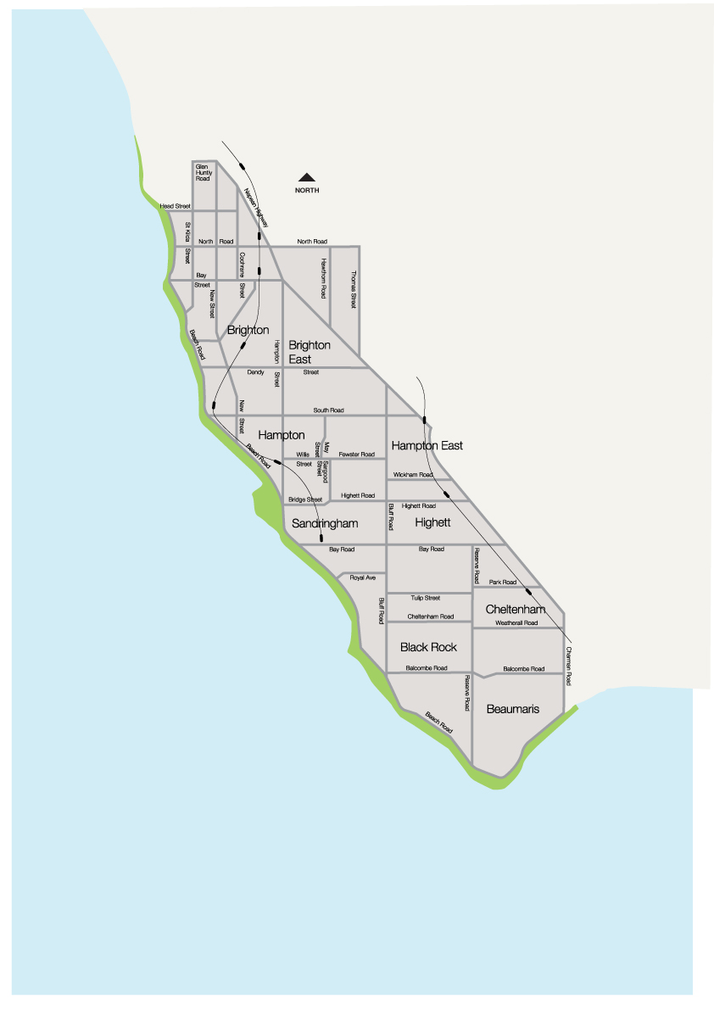

# 

# Appendix 2 – Bayside pruning zones

https://www.bayside.vic.gov.au/services/trees-parks-and-beaches/our-street-tree-maintenance-program-and-pruning-schedule

# Appendix 3 – VPO3 area (shaded green) – Black Rock, Beaumaris and part of Cheltenham

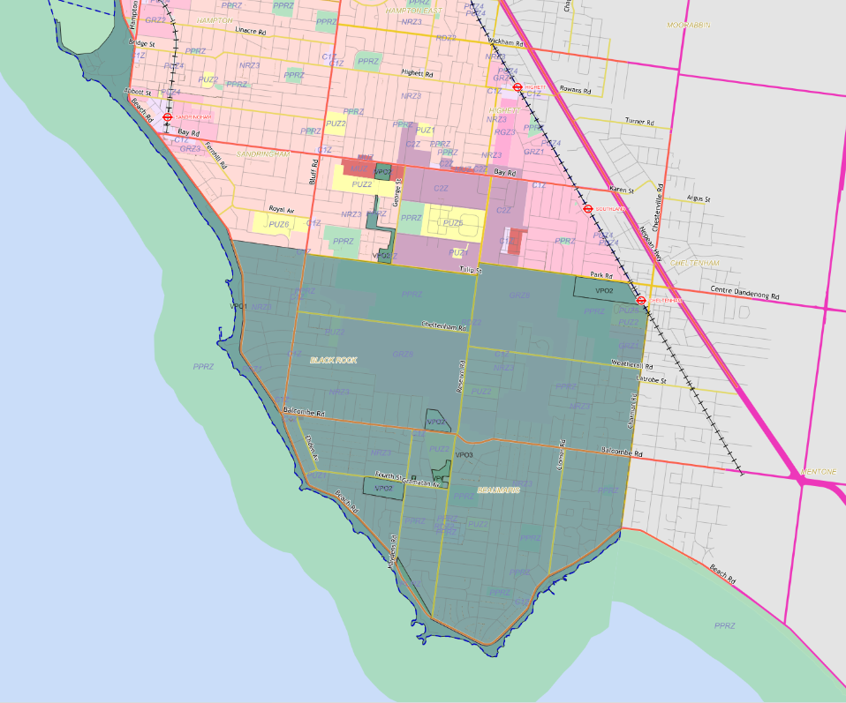

# Appendix 4 – Significant trees in public open space

|  |  |  |  |
| --- | --- | --- | --- |
|  | **Species of Trees** | **Location** | |
| 1 | Stand of *Banksia integrifolia* | Garden areas surrounding the Ricketts Point Tea House | |
| *2* | *Banksia integrifolia* | Beach Road opposite Burgess Street | |
| *4* | *Row of Eucalyptus cladocalyx* | Tovell Street, Brighton | |
| *5* | *Eucalyptus cladocalyx* | Corner Church and Dendy Streets, Brighton | |
| *6* | *Corymbia ficifolia* | Entrance to Cheltenham Park | |
| *7* | *Eucalyptus camaldulensis* | Infant Welfare Centre in Illaroo Reserve, Beaumaris | |
| *8* | *Ficus macrophylla* | Billilla, Halifax Street, Brighton | |
| *9* | *Quercus canariensis* | Kamesburgh Gardens North Road, Brighton | |
| *10* | *Cupressus macrocarpa* | Kamesburgh Gardens North Road, Brighton | |
| *11* | *Macadamia integrifolia* | Kamesburgh Gardens North Road, Brighton | |
| *12* | *Araucaria columnaris* | Kamesburgh Gardens North Road, Brighton | |
| *13* | *Ulmus glabra 'Pendula' x2* | Kamesburgh Gardens North Road, Brighton | |
| *14* | *Quercus robur cv* | Kamesburgh Gardens North Road, Brighton | |
| *15* | *Magnolia grandiflora* | Kamesburgh Gardens North Road, Brighton | |
| *16* | *Banksia integrifolia* | Crescent Gardens, Sandringham | |
| *17* | *Eucalyptus camaldulensis* | Whyte Street Reserve Northern Boundary | |
| *18* | *Araucaria heterophylla* | Billilla, Belle Avenue | |
| *21* | *Ulmus pendula* | Brighton Library Gardens Brighton | |
| *22* | *Quercus suber* | Brighton Library Gardens Brighton | |
| *23* | *Eucalyptus sideroxylon x 4* | Carpenter Street North end along Railway Line | |
| *24* | *Eucalyptus cladocalyx x 2* | Neighborhood Park on cnr of Chavasse and North | |
| *25* | *Eucalyptus camaldulensis* | Pocket Park, Chevasse Street | |
| *26* | *Ficus macrophylla* | Black Rock House, Ebden Ave, Black Rock | |
| *27* | *Corymbia ficifolia* | 6 Wall Street | |
| *29* | *Eucalyptus camaldulensis* | Beaumaris Kindergarten, 60 Wells Rd Beaumaris | |
| *30* | *Brachychiton populneus x 2* | 16 Westley Ave, Brighton | |
| *31* | *Quercus pallustrus* | | Avenue of trees between Bluff Rd Moorabbin St |
| *32* | *Washingtonia filifera* | | 20 New Street Brighton |
| *33* | *Melaleuca quinquenervia* | | 36 Glebe Street Cheltenham |
| *34* | *Eucalyptus cladocalyx* | | 29 Seymour Grove, Brighton |

# Appendix 5 Dispute Resolution Matrix

**Issue resolved**

**Issue not resolved – refer to CEO**

**Issue not resolved –**

**Refer to Director - Community and Customer Experience**

**Issue resolved**

**Discussion with Open Space Contract Manager , Open Space & Recreation**

**Issue resolved**

**Discussion with Open Space Contract Manager, Open Space & Recreation**

**Issue not resolved – refer to ESV**

**Issue not resolved –**

**Refer to United Energy**

**Issue resolved**

**Internal Dispute Resolution**

**External Dispute Resolution**

# Appendix 6 Table outlining KPI’s for audit program

|  |  |
| --- | --- |
| **Electric Line Clearance Audits – Council and Citywide Treecare** | |
| **Bayside City Council** | **Number of trees** |
| No of street trees | 46,744 |
| 10% street trees | 4,674 |
| Number of trees under power lines | 24,531 |
| 10% required annual audit (2 year cycle) | 2,453 |
| Council | |
| Zone post works | 10 |
| Total trees audited per year by Council | 3,000 |
| Number of trees audited per zone audit | 300 |
| Citywide | |
| Zone inspection audit – results reported at operational contract meeting | 10 |
| Zone post audit – results reported at operational contract meeting | 10 |
| Structural Branch Annual Audit | 351 |
| **Safety Audits - Citywide** | |
| **Description** | **Number of audits per year** |
| Citywide Vegetation Management around powerline audit - undertaken by responsible person results available at Contract meeting  **Vegetation Management around powerline audit** will include :  Do cutter and spotter have the following up to date competencies :   * Name of cutter * Training and licences – outlining completion date and competency * Safe Approach Distance/Working Near Overhead power lines (Annual) * CPR (Annual) * First Aid (3 yr) * High Risk Licence over 11mtrs (WP) (5 yrs) * AQF3 Climbing Competency – if required * Spotter –is this their sole responsibility e.g. not on chipper, picking up branches, etc?   Audit will also include:   * Prestart and Hazard Assessment on all vehicles * Site set up, including traffic and pedestrian management * Safe Approach distances for Elevated Work Platform, climbers for all powerlines * Safe Approach Distances (mm) for Vegetation Management Work near OH lines when working from an insulated EWP * Permits as required - suppression * Personal Protective Equipment * Emergency Response | 12 |
| **Safety Audits - Council** | |
| **Description** | **Number of audits per year** |
| * + - 1. Is the area free of public trip hazards?       2. Do all crew members have appropriate licenses?       3. Is there a well-stocked first aid kit onsite and working fire extinguisher?       4. Has the contractor identified any high risk activities in their documentation for this project? What are they?       5. Current and relevant SWMS documentation completed correctly.       6. Are the details identified on the SWMS consistent with the activities being undertaken on site?       7. Are all workers on-site wearing PPE needed for the task they are undertaking?       8. Is there a traffic / pedestrian management plan documented, in place and being followed?       9. Have pre-start checks been completed for all mobile plant, equipment and machinery.       10. Visually inspect mobile plant, equipment and machinery for any obvious defects listed or not listed on the documentation.       11. Is the waste and debris from the site being disposed of as per the relevant safety and environment requirements.       12. Are you aware of any OHS incidents (minor or severe) that have occurred on this site / visit to date? | 10 |

# Appendix 7 – Schedule 2 – Applicable distance for middle two thirds of a span of an electric line – all areas

# Graph 1 – Insulated electric lines in all areas



### Graph 1 formula

The formula by which the applicable distance for the middle 2 thirds of an electric line span to which clause 24 applies is calculated as follows:

For 0 < SD ≤ 40, AD = 300 mm

For 40 < SD ≤ 100, AD = 300 + ((SD - 40) × 10)

For 100 < SD, AD = 900 mm

*Where:*

SD = Span Distance

AD = Applicable Distance

**Notes to Graph 1**

(1) The applicable distance includes allowances for sag and sway of the conductor.

(2) The minimum clearance space for an electric line span to which this Graph and clause 24 apply is partially illustrated in Figures 1, 2 and 3.

(3) The applicable distance for the first and last sixths of an electric line span to which clause 24 applies is 300 millimetres.

# Graph 2 – Uninsulated low voltage electric line in Low Bush Fire Risk Area

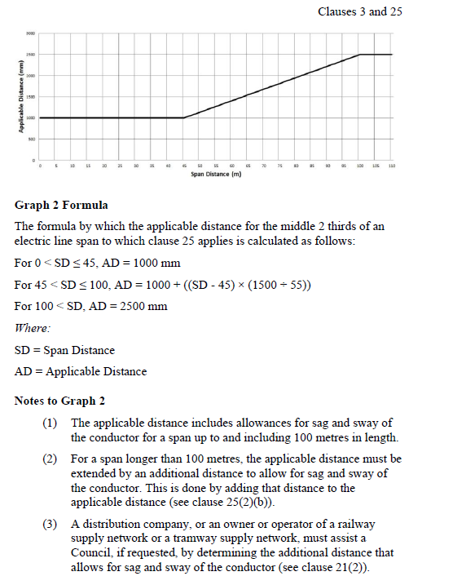

### Graph 2 formula

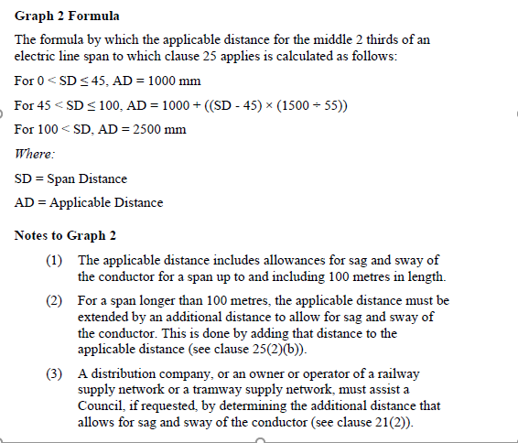

# Graph 3 – Uninsulated High Voltage Electric Line (other than 66kV line) in LBRA

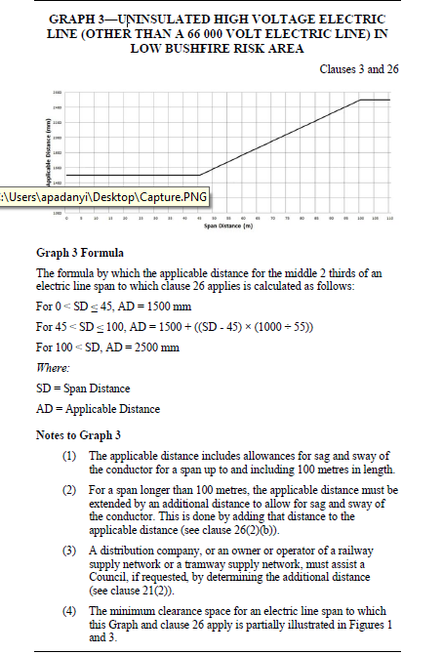

### Graph 3 formula

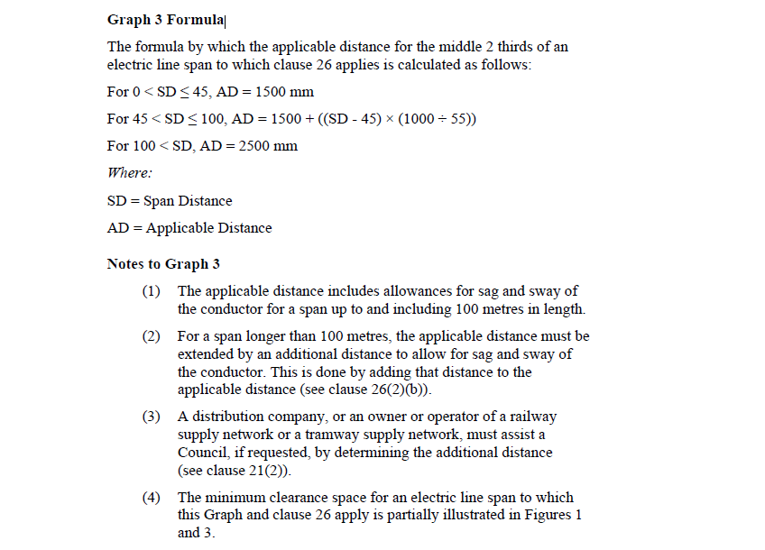



# Graph 4 – Uninsulated 66kV line in LBRA

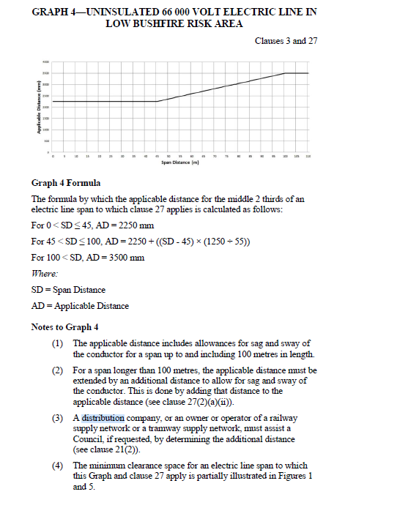

### Graph 4 formula

