Bayside Public Toilet Strategy
2024-2028

Table of Contents
PART A. 3
1. Executive Summary 3
Purpose 3
Council’s role 3
Key issues and findings 3
Our Vision 3
Goals and strategic objectives 4
PART B. 5
2. Purpose 5
3. Glossary 6
4. Legislative and policy and context 7
5. Vision statement 7
6. Council’s Strategic Planning Framework 8
7. Scope 9
8. Methodology 9
Research 9
Analysis 9
Criteria 10
Community Engagement 10
9. Key issues and findings 11
10. Goals, strategic objectives, and action plan 14
11. Implementation and reporting 16
12. Financial resources 16
13. Potential program of capital works 17
14. Appendix A – List of Council-managed facilities 19
15. Appendix B – Map of Council public toilet facilities 21
16. Appendix C – Condition Assessment of Public Toilets 22

PART A.

Executive Summary

Purpose
The Bayside Public Toilet Strategy 2024-2028 summarises Council’s approach to providing and managing public toilet facilities and includes 70 public toilets (including 2 Changing Places).
The Public Toilet Strategy was adopted by Council resolution on 21 May 2024 and shall be in effect for four years.

Council’s role
There is no legislative requirement for Council to provide public toilets, however they are a service that is much valued by the community in supporting the use of Bayside’s parks and reserves, facilities, and activity centres.
Council’s role is to plan and deliver new facilities to support demand, maintain and clean existing public toilets, and replace aging or ineffective facilities. Council must provide this service in a way that is financially sustainable.

Key issues and findings
A number of key issues were identified in the development of this Strategy:
- Equality and Inclusion – it is recommended that Council continue to replace older public toilets assets with modern, accessible, and inclusive facilities.
- Changing Places - Changing Places are an important asset and allow people with high support needs and their carers to plan and enjoy various activities throughout Bayside. A key part of the Strategy is the development of criteria to prioritise the location of new facilities.

Our Vision
Council’s vision is for public toilet facilities to be accessible, inclusive, and safe for all users.
- Accessible means that facilities can be used by anyone regardless of ability
- Inclusive means facilities that do not discriminate based upon background, experience, or identity.
- Safe means appropriately designed and constructed facilities which are well-maintained and regularly cleaned.

Goals and strategic objectives
The following goals and objectives were identified:
- Our community values accessible infrastructure which supports a range of abilities
- Our community values infrastructure which is safe and inclusive for all users
- Our community can expect a quick response when a facility is damaged, vandalised or requires cleaning
- Our community can expect that public toilets are in good condition and function correctly
Capital Works Program
The renewal of the following existing public toilet facilities is recommended:
- Brighton Beach Southern Terrace toilet
- Balcombe Road carpark toilet
- Beaumaris Concourse toilet
- Ricketts Point Bluestone toilet
Community Engagement
The Public Toilet Strategy was open for community engagement between 26 February and 2 April 2024. It received 588 contributions, showing high levels of support for the vision, strategic objectives, and capital works plan.
Major themes during engagement were cleaning, maintenance, and safety of public toilets.

PART B.

Purpose
The Bayside Public Toilet Strategy 2024-2028 summarises Bayside City Council’s approach towards the management of public toilets. As of 2023, there are presently 70 public toilet facilities in Bayside including two Changing Place facilities for people with higher support requirements. A complete list and map of Bayside’s public toilet facilities is shown in Appendices A and B.
A key component of the Strategy is the proposed capital works program which shall guide major improvements to public toilets (including Changing places) in Bayside over the next four years.
The previous iteration of the Strategy (Bayside Public Toilet Strategy 2019-2023) delivered the following capital works program:
- a new ambulant and accessible facility at Green Point, Brighton.
- an expanded facility (including accessible and Changing Place cubicles) in Well Street, Brighton.
- a replacement facility (including ambulant, accessible, and Changing Place cubicles) at Thomas Street Reserve, Hampton.
- Minor upgrades to several facilities.

Glossary
Term | Definition
Public Toilet | A toilet facility that provides amenity services to the general public.
External Facing | An ‘external facing’ facility includes standalone facilities or those which are part of a major building but with independent access. External facing facilities are the primary focus of this Strategy.
Internal Facing | An ‘internal facing’ facility is part of a larger building and is intended for the use of its occupants. Internal facing facilities are not within the scope of this strategy.
Non-accessible | A cubicle that does not meet minimum accessibility standards.
Ambulant | A cubicle designed for those with ambulant disabilities that do not require the extra space to use a wheelchair.
Accessible | A cubicle with additional space, lowered sinks, and additional grab bars designed for people who require the use of a wheelchair.
Changing Places | A facility designed for users and their carers with high support requirements and includes a change table, hoist, shower, and greater internal space. Changing Places are ‘external facing’ and always available to carers provided they have the appropriate key.
Accessible Adult Change Facility | An Accessible Adult Change facility is similar to a Changing Place but is ‘internal facing’. They support the use of a single facility and are only available to users of that facility when it is open.
CPTED | Crime Prevention Through Environmental Design (CPTED) is the design of buildings or public spaces to reduce the likelihood of antisocial activity. This may include minimising opportunities for concealment or improving passive surveillance.

Legislative and policy and context

There is no legislative requirement for Council to provide standalone public toilets (except as part of major facilities), however they are a service that is much valued by the community that enhances enjoyment of Bayside’s community facilities, open space and recreational reserves, and commercial precincts.
Disability Discrimination Act 1992
The Disability Discrimination Act 1992 (DDA) legislates for the protection of all Australians from discrimination based on a disability and remove barriers to participation. The DDA is highly relevant when providing public infrastructure such as toilets and ensuring that they are accessible and operable for all users.
Gender Equality Act 2020
The Gender Equality Act 2020 requires that gender impact assessments are to be undertaken to ensure all people have equal access to community infrastructure and services. At Bayside, these are expanded into Equity Impact Assessments (EIAs) which consider a broader range of impacted groups.

The following Council documents are also relevant to the provision of public toilets throughout Bayside:
- Asset Plan 2023-2032
- Sustainable Building and Infrastructure Policy 2022
- Service Driven Asset Management Policy
- Disability Action Plan 2021-2025
- Municipal Public Health and Wellbeing Plan 2021–25
- Active by the Bay Recreation Strategy 2013-22
- Bayside Open Space Strategy
- Bayside Sportsground Pavilion Improvement Plan

Vision statement
Council’s vision is for public toilet facilities to be accessible, inclusive, and safe for all users.
- Accessible means that facilities can be used by anyone regardless of ability.
- Inclusive means facilities that do not discriminate based upon background, experience, or identity.
- Safe means appropriately designed, located, and constructed facilities which are safe to use, well-maintained and regularly cleaned.
This vision was developed with consideration of Bayside’s 2050 Community Vision and related Council documentation.

Council’s Strategic Planning Framework
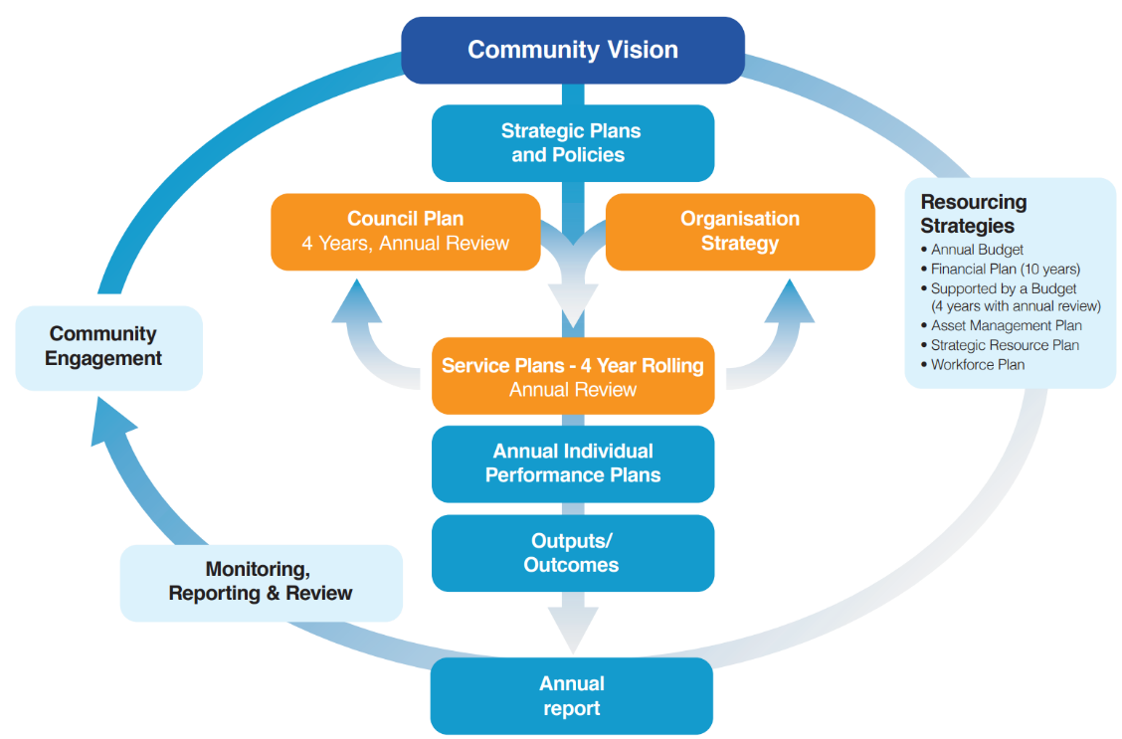
The Bayside 2050 Community Vision was developed by a representative community panel of local residents and sets out a guiding framework of what the community thinks Council should be working towards. This document developed 10 long-term ‘themes’ to guide Council on delivering services which are valued by the Bayside community.

The Public Toilet Strategy is a strategic service plan and seeks to deliver a service which is consistent with the Community Vision.
The most relevant themes which the Strategy delivers on are:
- Theme 3: Transport, Walkability and Rideability – public toilets support active modes of transport and often provide useful infrastructure such as drinking fountains, baby change facilities, and in some cases bicycle repair stations.
- Theme 4: Community Feel and Direction – public toilets support the use of open space, recreation, and commercial precincts throughout Bayside by allowing people to plan activities and spend longer in these spaces.
- Theme 8: Access and Inclusion – Council strives to deliver public toilet facilities which are available for all users regardless of background, experience, or identity.
- Theme 9: Built Environment – Council seeks to deliver public toilets which are safe, accessible, inclusive, and well-maintained with minimal impact to the natural environment.
- Theme 10: Tourism, Commercial and Economic Opportunities – Public toilets support enjoyment of Bayside’s open space, recreation, and commercial precincts and result in increased economic benefit.
The Strategy shall also directly contribute to Objective 3.2 of the Council Plan 2021-2025 in providing safe, accessible, and inclusive infrastructure for the whole community.

Scope
The Bayside Public Toilet Strategy will summarise how Council manages Bayside’s 70 public toilet facilities (including two Changing Places).
The Strategy will consider Council-managed ‘external facing’ facilities only. This includes standalone facilities but also public toilets that are on the outside of a larger Council building and can be accessed when that building is closed. ‘Internal facing’ toilets which can only be accessed from inside a building are not within the scope of this Strategy.
In some cases, other Council programs will result in the construction or upgrade of new public toilets, and these facilities have been removed from consideration under the Strategy.

Methodology
The development of the Public Toilet Strategy followed the following key steps:

Research
One of the earliest stages of development of this Strategy was an Equity Impact Assessment (EIA) where officers were asked to consider and assess the potential for impacted groups in the community to be affected by this proposal. The impacted groups considered included gender, disability, age, race, culture, religion, literacy, neurodiversity, socioeconomic, homelessness, and social isolation. While Council’s intention is to provide facilities which are inclusive of the whole community, considering and hearing (via community engagement) from impacted groups can further improve the service outcome.

Analysis
Council has carried out an audit of all existing public toilets across Bayside to assess each facility’s condition, capacity, and function. Historic inspection, maintenance, and cleaning data was also reviewed to indicate which toilets were most prone to breakdown or overuse.
The condition of individual facilities is frequently a driver for replacement. Council can often continue to maintain a facility or carry out replacement of internal fittings or even structural elements such as the roof. However, at some stage the cost of maintaining the facility may become unreasonable and replacement should be considered. It is important to note that cleanliness and graffiti do not determine a structure’s overall condition.
Of particular interest in this assessment was how well each toilet performed in accordance with accessibility standards and requirements. This data was analysed to determine which toilets offer an appropriate level of access and identified facilities which would benefit from improvement.

Criteria
It is acknowledged that there may be a perceived need for a toilet in many locations throughout Bayside, however the cost of implementing and managing such a network would be excessive.
The following criteria have been proposed to help Council identify and prioritise the need for new facilities. Public toilet facilities which are prioritised under this Strategy should reasonably satisfy the following criteria:
- The new location supports a Council facility, open space or recreational reserve, or activity centre.
- There is available Council land for a new public toilet, and it can be appropriately located from a safety (CPTED) perspective.
- There is no other public toilet within 400m.
- The facility can be reasonably constructed and maintained by Council’s contractors.
- Changing Places are rationalised to support a range of activities (e.g. playgrounds, recreation, foreshore, commercial activity) and there is no other Changing Place within 2km.
New toilets may also be proposed under other Strategic Service Plans which may have different criteria to support their services. Some of these criteria include:
- Under the Bayside Open Space Strategy, public toilets should be provided in all ‘municipal/regional’ open space reserves.
- Under the Bayside Playground Improvement Plan, public toilets should be provided in all ‘municipal/regional’ playgrounds.
- Under the Bayside Sportsground Pavilion Improvement Plan, amenities are recommended to support the community space around sports facilities (i.e. spectators).

Community Engagement
To understand the lived experience of community members with accessibility needs, Bayside’s Disability Access and Inclusion Advisory Committee (DAIAC) was engaged throughout the development of the Strategy, with a focus on the provision of Changing Places facilities.
A comprehensive community engagement program was undertaken to refine the Strategy between 26 February and 2 April 2024. This was timed to coincide with the summer period when public toilets are in high use, particularly along the foreshore.
A range of engagement methods were used to gather feedback including an online survey, interactive social map, and meetings with representative committees.
Participation was incentivised through a competition to win a year’s supply of toilet paper.

Key issues and findings

Accessibility
Many of Bayside’s public toilet facilities have been constructed since the introduction of the Disability Discrimination Act 1992 and have some level of accessible facility either through construction or retrofit.
Bayside has an aging demographic and many people may experience mobility or strength issues related only to healthy aging. Improving the accessibility of public toilets makes them safer and easier to operate for users and is of significant benefit to the whole community.
Recommendation: Older public toilets shall be gradually replaced or upgraded to meet or exceed modern accessibility compliance.
Gender
During review of the Bayside Sportsground Pavilion Improvement Plan, Council resolved that toilet facilities in sporting pavilions were to be gender neutral to support an increase in female participation in sport.
This principle has been extended to previous Public Toilet Strategies with only gender-neutral facilities being constructed in recent years. This removes limitations to full utilisation so that users may occupy any vacant cubicle.
Gender neutral facilities allows for public toilets to be safely and comfortably used by:
- A child who is escorted by their parent, guardian, or carer of the opposite sex.
- A person with a disability who require the assistance of a carer of the opposite sex.
- Gender diverse people.
Gender-neutral facilities also allow for the full capacity of a toilet block to available to all users.
Recommendation: Gender-specific facilities shall continue to be replaced with gender neutral facilities as in previous years. Facility signage should also be reviewed to further encourage usage by all members of the community.
Changing Places
Changing Places are an important asset and allow people with high support needs and their carers to plan and enjoy various activities throughout Bayside.
Council presently has two active Changing Places at Thomas Street Reserve and Well Street carpark with three more proposed or under consideration:
- Yalukit Willam Nature Reserve
- Beaumaris Arts Group
- Dendy Park Athletics Pavilion
Changing Places are access controlled and as such do not duplicate the function of an accessible public toilet, requiring both facilities to be provided. Constructing ambulant, accessible and Changing Places in one location increases both the footprint and cost of a new public toilet facility.
Improved cost efficiency can be found by considering new facilities as part of larger public toilet facilities or major buildings. Larger buildings will often provide additional benefits such as car parking which is essential for Changing Places to be effective.
Recommendation: Changing Places or Accessible Adult Change facilities should be considered in all new major Council buildings, subject to the Strategy criteria in Part 7: Methodology.
Network Gap
Public toilets provide a supporting role to various Council services. While public toilets would be valuable in many locations, it is important for Council to not exceed available budget and resources to manage its facilities.
Council has proposed a number of criteria to prioritise facilities which support council services, active and passive recreation, and commercial activity.
Recommendation: New toilets proposals shall be considered based upon the Strategy criteria in Part 7: Methodology.

Automated Facilities
Automated facilities are often pre-constructed for ease of installation, have a small footprint, and features such as an automated door. Some of these facilities have increased operating costs, and no longer meet modern compliance standards.
Recommendation: Council will look to replace older automated facilities with automated or non-automated modern and non-proprietary facilities. Automated facilities will be considered primarily where existing electrical connections are established.
Utilisation
While most Council facilities are staffed by officers or a tenant, public toilets are not currently monitored for usage. This can make it difficult for Council to determine which facilities are undersized or may not be required.
Council has previously investigated the implementation of data counters. Such counters can be implemented to determine the number of times a threshold is crossed, a door is opened, or a toilet is flushed and give officers accurate data around where capital works should be prioritised.
Data counters do not include any form of camera or microphone recorder and are capable only of counting.
Recommendation: Council shall undertake a pilot of data counters with a plan to expand their usage throughout the public toilet network.
Maintenance Challenges
Public toilets can be a difficult building asset to maintain and kept clean. They are unstaffed, exposed to weather, and frequent targets of vandalism and misuse.
Recommendation: Council shall seek to improve the balance of comfortable yet hardened facilities. Building materials and components should be easy to source (i.e. locally), user-friendly, and resistant to wear, vandalism, and graffiti.
Community Engagement findings
The Strategy was open for community engagement between 26 February and 2 April 2024. This was planned to be after summer where utility of public toilets was at its highest.
The Disability Access and Inclusion Advisory Committee (DAIAC) and Bayside Healthy Aging Reference Group (BHARG) also participated as focus groups. Both groups generally supported most actions.
Wider community engagement received 588 contributions from a combination of survey, social map, and direct email submissions via Council’s Have Your Say page. It found high levels of support for the vision, most strategic objectives, and the capital works plan. Cleanliness, maintenance, and safety were major themes from engagement.
More details are provided in the Community Engagement Report on Council’s Have Your Say page.

Goals, strategic objectives, and action plan
The Bayside Public Toilet Strategy shall encompass two strategic objectives which relate to the themes of the Bayside 2050 Community Vision and Council Plan 2021-2025.
Goal 1: Our community values equity and inclusivity
Strategic objective 1: Our community values accessible infrastructure which supports a range of abilities
Actions | Timeframe | Strategic Indicators
Improve public toilet asset service level standards. Ensure that new public toilets meet a high standard of accessibility, beyond minimum compliance levels. | 2025 | - Develop a design guide to ensure that new facilities meet minimum and/or desired standards  - Increased number of accessible public toilet facilities
Carry out minor capital works and maintenance which improves the accessibility of a facility towards or beyond compliance | Ongoing
Replace older facilities with modern facilities which meet and exceed modern accessibility standards and are available to all users. | 2025-2028

Strategic objective 2: Our community values infrastructure which is safe and inclusive for all users
Actions | Timeframe | Strategic Indicators
Replace older facilities with modern facilities which meet and exceed modern accessibility standards and are available to all users. | 2025-2028 | - Increased number of gender-neutral public toilet facilities
Review and adopt gender-neutral signage for public toilet facilities. Gradually implement gender-neutral signage as replacement is needed | Ongoing
Goal 2: Our community values safe, clean, and fit-for-purpose infrastructure
Strategic objective 1: Our community can expect a quick response when a facility is damaged, vandalised or requires cleaning
Actions | Timeframe | Strategic Indicators
Adopt and implement non-invasive data counters to improve proactive cleaning schedule. | Ongoing | - Improved response times for maintenance, cleaning, and vandalism requests  - Improved strategic planning for public toilets in Bayside
Investigate development of an improved toilet identification sign which includes both a phone number and a QR code to report faults, vandalism, or mess. | 2024/25

Strategic objective 2: Our community can expect that public toilets are in good condition and function correctly
Actions | Timeframe | Strategic Indicators
Additional funding to renew and upgrade toilet components and improve accessibility | Annual | - Increase the overall condition profile of Bayside’s public toilets
Replace older facilities with modern facilities which meet and exceed modern accessibility standards and are available to all users. | Ongoing
Investigate expansion of the Middle Brighton Baths to add additional capacity | 2024/25 | - Prepare feasibility report for increasing capacity of the Middle Brighton Baths facility

Implementation and reporting
The Bayside Public Toilet Strategy shall be delivered through a combination of operational and capital programs (See Part 13: Program of Capital Works).
Inspection, maintenance, and cleaning of public toilets shall continue to be managed through Council’s facility maintenance and cleaning contracts. Minor capital works will be managed by Council’s Facilities Maintenance team while major new, upgrade, or renewal works will be managed by the Project Services team. Council’s Assets team shall be responsible for overseeing implementation of the Strategy and reporting.

Financial resources
Cleaning and maintenance of public toilets will be resourced within Council’s existing operational budget and delivered through Council’s facility maintenance and cleaning contracts.
New, upgraded, and renewal of public toilets shall be funded from Council’s capital works program. The Public Toilet Strategy shall outline the funding requirements and capital works program for 2024-2028. This budget may be supplemented with State Government grants for new Changing Places where possible.

Program of capital works
To deliver the strategic objectives outlined in this Strategy, the following program of capital works program is proposed.
Priority (or timeframe) | Capital project | Estimated costs
2024/25 | Renewal of Brighton Beach Southern Terrace public toilet (TOI31)  The existing toilet block will be replaced with a new facility in the same location, including 6-8 standard/ ambulant, an accessible cubicle, and an outdoor shower. | $700,000
2025/26 | Renewal of Balcombe Road carpark public toilet (TOI12)  The existing toilet block will be replaced with a new facility in the same location, including a mix of ambulant and accessible cubicles. | $350,000
2026/27 | Renewal of Beaumaris Concourse public toilet (TOI09)  The existing toilet block will be replaced with a new facility in the same location, including an ambulant and accessible cubicle. | $450,000
2027/28 | Replacement of Ricketts Point Bluestone Foreshore toilet (TOI36)  The existing toilet block would be replaced including a mix of standard, ambulant, and accessible cubicles. Investigations would be undertaken to consider the opportunity of including a Changing Places facility at this location, noting that this is not currently included in estimated costs. | $450,000
2025-2028 | Public Toilets – Minor Works and Accessibility Improvement  Additional budget provided to Council’s public toilet minor works program for improving accessibility | $75,000 per year
Audit of existing public toilets
New or Renewed Facilities
Minor Service Upgrades
Minor Renewal and Improvement
Review service levels
Construct new facilities

Renewal of existing facilities

Replace or improve building components (i.e. roof, door)
Implement data counters
Review and update signage
Maintenance
Cleaning
Maintenance and cleaning contracts
Inspections and Customer Requests
Graffiti Removal
Figure 1 Public Toilet operational, renewal, and upgrade programs

Appendix A – List of Council-managed facilities
Below is a list of all public toilet facilities managed by Council and may be read in conjunction with the map in Appendix B. As several Council programs may deliver new toilets, some of these facilities have been excluded from consideration under this Strategy. The ‘TOI’ toilet number is provided on most toilets to make it easier to report maintenance and cleaning issues.
Facilities below shaded in green have recently been constructed, red are being replaced under a different program, and blue are being replaced under this Strategy.
Toilet Number | Facility Name | Status
TOI01 | Elsternwick Park Pavilion 2 Public Toilet | Recently constructed
TOI02 | Balcombe Park Public Toilet
TOI03 | Banksia Reserve Pavilion Public Toilet
TOI04 | Basterfield Park Public Toilet
TOI05 | Marion Street Carpark Public Toilet
TOI06 | Trevor Barker Beach Oval Public Toilet
TOI07 | Middle Brighton Baths Public Toilet | Investigation proposed to determine feasibility of expanding this facility to increase capacity.
TOI08 | Beaumaris Sports Reserve Pavilion Public Toilet | Recently constructed
TOI09 | Beaumaris Concourse Public Toilet | Proposed for renewal under Public Toilet Strategy 2023-2028
TOI10 | Billilla House Historic Public Toilet
TOI11 | Black Rock Gardens Public Toilet
TOI12 | Balcombe Road Carpark Automated Public Toilet | Proposed for renewal under Public Toilet Strategy 2023-2028
TOI13 | Half Moon Bay Life Saving Club Public Toilet | Planned reconstruction under the Half Moon Bay Masterplan
TOI14 | Brighton Beach Reserve Public Toilet | Planned reconstruction under the Sportsground Pavilion Improvement Plan
TOI16 | Castlefield Reserve Pavilion Public Toilet
TOI17 | Cheltenham Park Pavilion Public Toilet
TOI18 | Cheltenham Recreation Reserve Public Toilet
TOI19 | Jetty Road Kiosk Public Toilet
TOI20 | Dendy Park Pavilion Public Toilet
TOI21 | Dendy Park Athletics & Soccer Pavilion Public Toilet | Planned reconstruction under the Sportsground Pavilion Improvement Plan
TOI22 | Elsternwick Park South Public Toilet
TOI23 | Elsternwick Park Pavilion 1 Public Toilet
TOI24 | Green Point Foreshore Public Toilet
TOI25 | Hampton Life Saving Club Automated Public Toilet
TOI26 | Highett Grove Public Toilet | Planned reconstruction as developer contribution
TOI27 | Sandringham Foreshore Public Toilet
TOI28 | Hurlingham Park Pavilion Public Toilet
TOI29 | Jetty Road Foreshore Public Toilet
TOI30 | Keys Street Public Toilet
TOI31 | Brighton Beach Public Toilet | Proposed for renewal under Public Toilet Strategy 2023-2028
TOI32 | Southern Basketball Association Public Toilet
TOI33 | Landcox Park Public Toilet
TOI34 | Donald MacDonald Reserve Pavilion Public Toilet | Recently constructed
TOI35 | Beaumaris Foreshore Public Toilet
TOI36 | Ricketts Point Bluestone Public Toilet | Proposed for renewal under Public Toilet Strategy 2023-2028
TOI37 | Ricketts Point Foreshore Automated Public Toilet
TOI38 | Royal Avenue Parklands Public Toilet | Recently constructed
TOI39 | Sandringham Athletics Pavilion Public Toilet
TOI40 | Destructor Reserve Pavilion Public Toilet | Recently constructed
TOI41 | Tulip Street Baseball Pavilion Public Toilet | Planned reconstruction under the Sportsground Pavilion Improvement Plan
TOI42 | Trevor Barker Beach Oval Toilets & Shelter
TOI43 | Sandringham Station Automated Public Toilet
TOI44 | Shipston Reserve Pavilion Public Toilet
TOI45 | Sillitoe Reserve Pavilion Public Toilet | Recently constructed
TOI46 | Simpson Reserve Pavilion Toilet
TOI47 | Southey Street Foreshore Public Toilet | Recently constructed
TOI48 | Table Rock Foreshore Public Toilet
TOI49 | Dendy Park Public Toilet (Dacey Street)
TOI50 | Thomas Street Reserve Public Toilet and Changing Place | Recently constructed
TOI51 | Thomas Street Carpark Automated Public Toilet | Planned reconstruction under the Public Toilet Strategy 2019-2023
TOI52 | Dendy Park Public Toilet (playground)
TOI53 | Well Street Public Toilet and Changing Place | Recently constructed
TOI54 | Whyte Street Public Toilet
TOI55 | William Street Reserve Pavilion Public Toilet | Recently constructed
TOI56 | Willis Lane Carpark Public Toilet
TOI57 | Spink Street Public Toilet
TOI58 | Seaview Carpark Automated Public Toilet
TOI59 | Peterson Reserve Pavilion Toilet | Planned reconstruction under the Sportsground Pavilion Improvement Plan
TOI60 | North Road Foreshore Public Toilet
TOI61 | Dendy Village Automated Public Toilet
TOI62 | Sandringham Gardens Automated Public Toilet
TOI63 | Chisholm Reserve Pavilion Public Toilet
TOI64 | Kamesburgh Public Toilet
TOI65 | Jack Levy Pavilion Public Toilet | Planned reconstruction under the Sportsground Pavilion Improvement Plan
TOI66 | A W Oliver Pavilion Public Toilet
TOI67 | Green Point Parkland Toilet | Recently constructed
TOI68 | Black Rock Life Saving Club Public Toilet | Planned reconstruction
TOI69 | Brighton Recreation Centre public toilet
TOI70 | Yalukit Willam Nature Reserve | Yalukit Willam Nature Reserve Masterplan
- | Elsternwick South (playground) Public Toilet | Open Space Strategy
- | Beaumaris Arts Group Changing Place | Council Plan

Appendix B – Map of Council public toilet facilities
This is a map of Bayside showing all public toilet facilities listed in Appendix A. The buffer around the facilities is a 400m radius for public toilets and 2km for Changing Places.
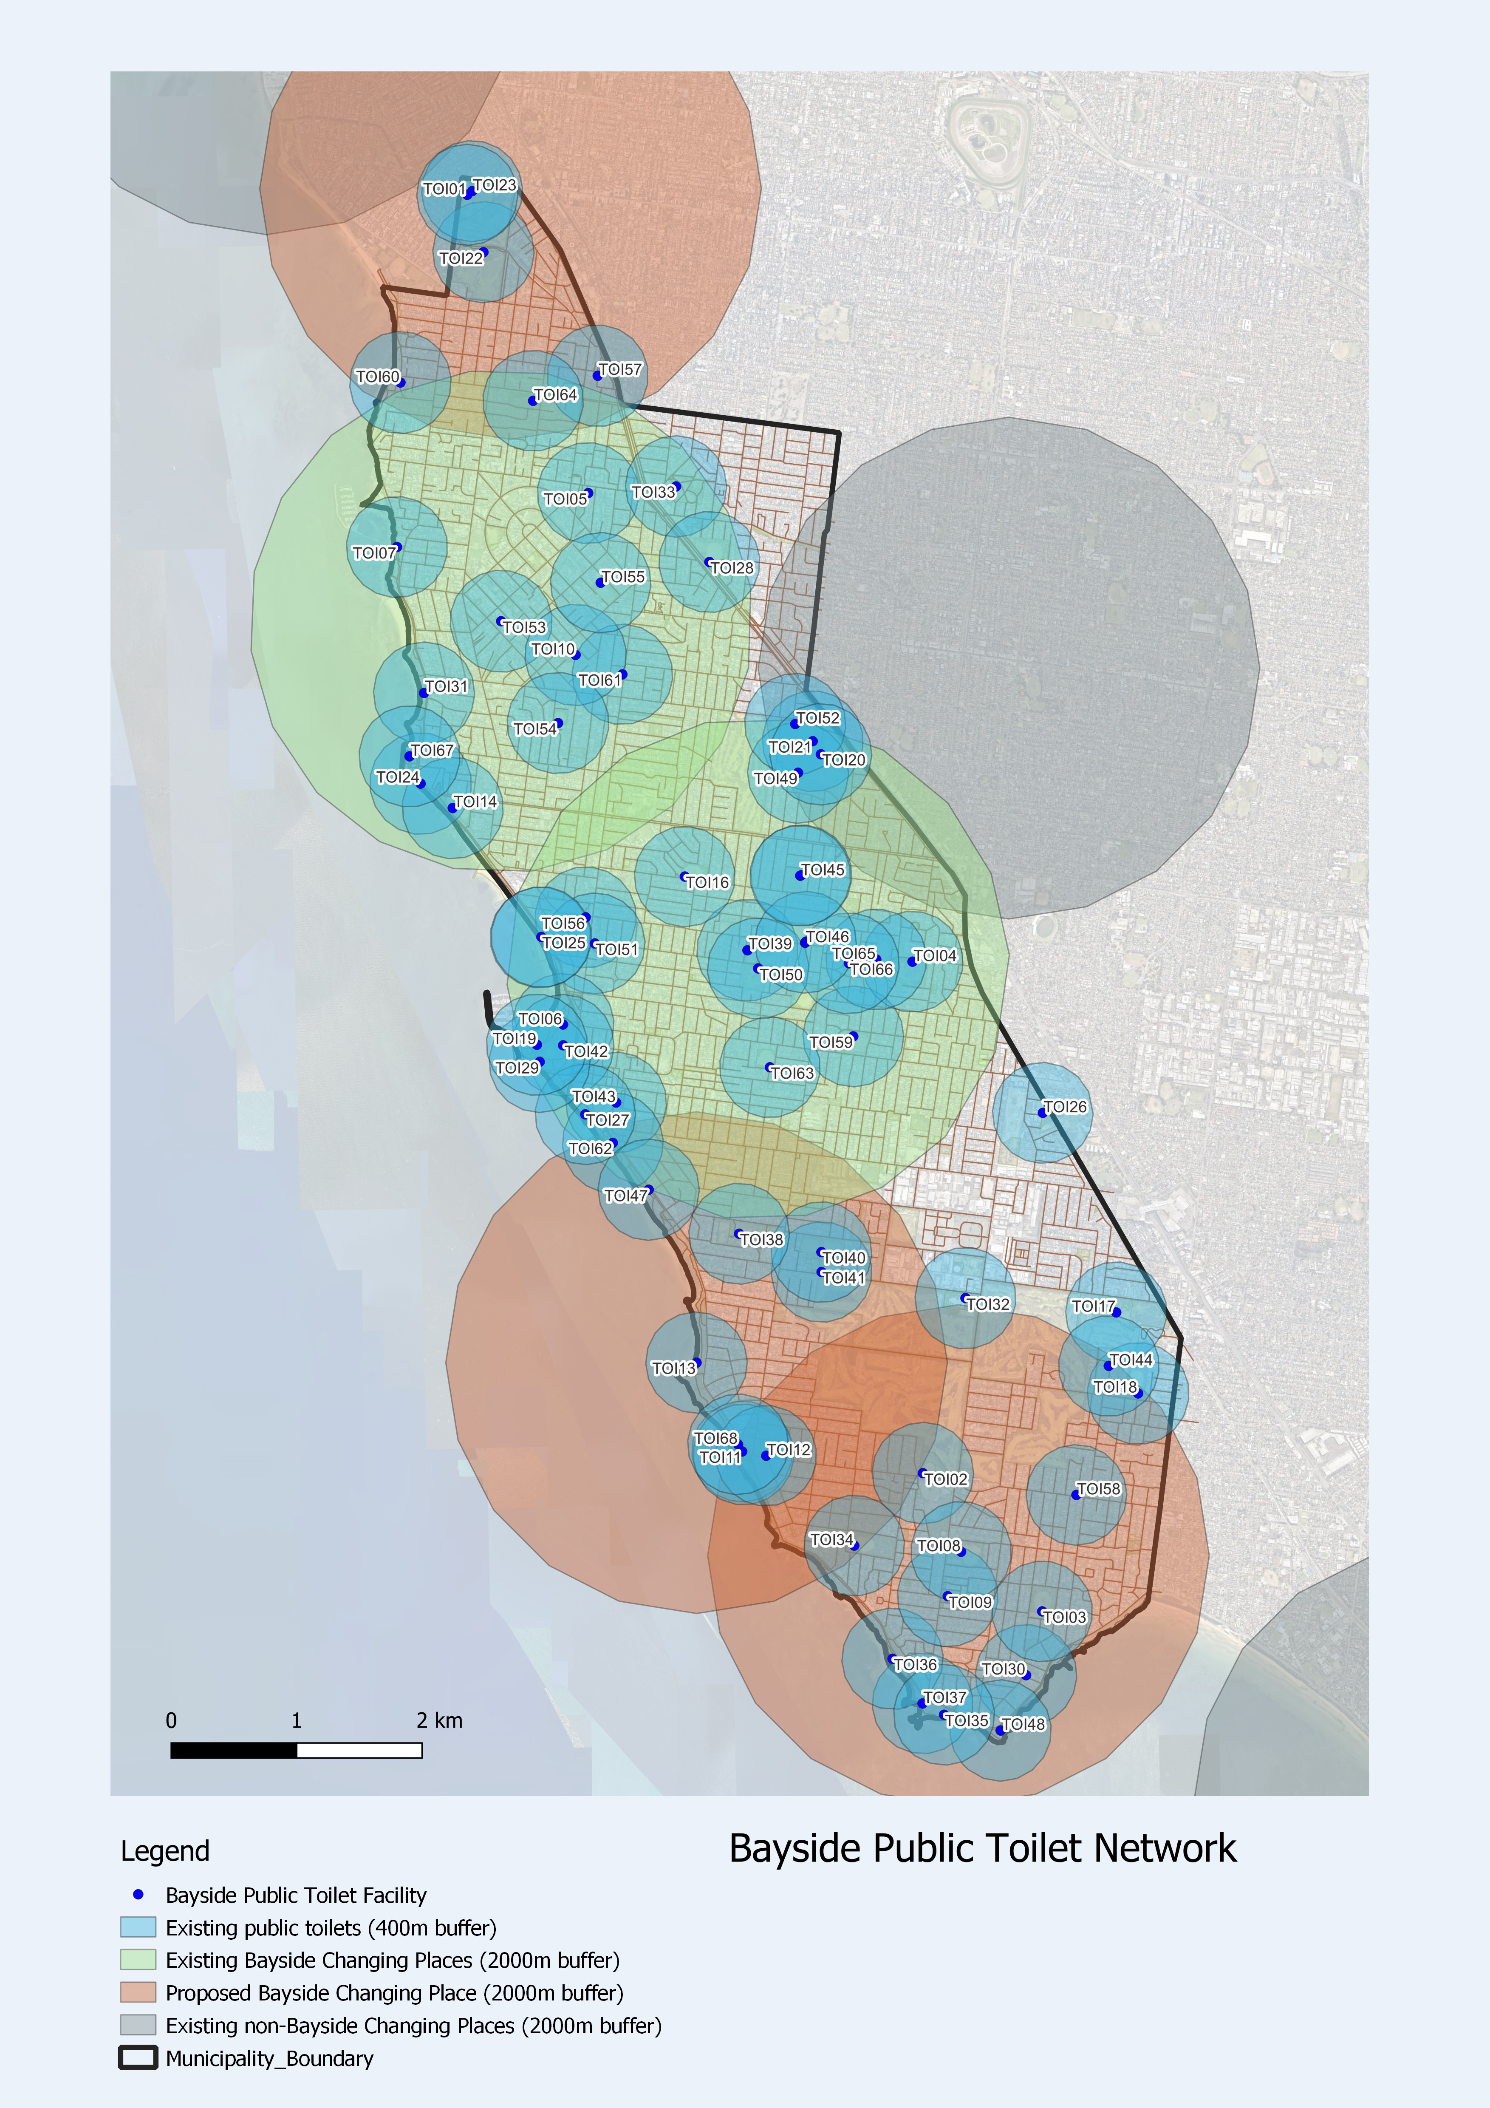

Appendix C – Condition Assessment of Public Toilets
Below are the results of Council’s condition assessment of Bayside’s public toilets in 2023. Toilets were also assessed based upon a number of other criteria including capacity and accessibility. See Appendix 1 for facility names.

